**Department of Electrical Engineering**

**EE 260: Electro Mechanical System**

**Labotary Manual**

|  |  |
| --- | --- |
| **Location: ______________**  **Semester: _____________** | **Time: ________________**  **Section: _____________** |
|  |  |

**Course Instructor:__________________**

List of Experiments

Lab1: Introduction to Three Phase Power System / CLO4-P4 3

Lab2: Analysis Of Three Phase Power System / CLO4-P4 9

Lab3: Examples of Faraday's Laws / CLO4-P4 15

Lab4: Eddy Currents and Laminated Cores / CLO4-P4 27

Lab5: Hysteresis Loop and Core Losses / CLO4-P4 35

Lab6: Single Phase Transformers / CLO4-P4 45

Lab7: Auto-Transformer / CLO4-P4 59

Lab8: Three Phase Transformer Connections & Operation / CLO4-P4 67

Lab9: Introduction to Machines / CLO4-P4 73

Lab10: Three Phase Alternator Characteristics / CLO4-P4 87

Lab11: Alternator Synchronization / CLO4-P4 99

Lab12: Squirrel Cage Induction Motor Characteristics / CLO4-P4 105

Lab13: Shunt and Series Dc Motor Characteristics / CLO4-P4 117

Lab14: Operating Characteristics for An Asynchronous Generator (Eddy Current Brake) / CLO4-P4 127

Lab15 Operating Characteristics of A Universal Motor / CLO4-P4 …….. 137

# 

# Department of Electrical Engineering

|  |  |
| --- | --- |
| **Faculty Member:____________________** | **Dated: ________________** |
| **Semester:__________________________** | **Section*: ________________*** |

**EE 260: Electro Mechanical System**

**Lab1: Introduction to Three Phase Power System**

|  |  |  |  |  |
| --- | --- | --- | --- | --- |
| **Name** | **Reg. No** | **Report Marks / 10** | **Viva Marks / 5** | **Total/15** |
|  |  |  |  |  |
|  |  |  |  |  |
|  |  |  |  |  |
|  |  |  |  |  |

**Lab1: Introduction to Three Phase Power System / P4**

**Objectives:**

**Conduct an experiment:**

* To learn measurements techniques on a three phase power system.
* To understand phase sequence.

**Equipment:**

|  |  |  |  |
| --- | --- | --- | --- |
|  | **Description** | **Module No.** | **Quantity** |
| 1 | Three phase power supply | EMS 8821 | 1 |
| 2 | Three phase resistive load | EMS 8311 | 1 |
| 3 | Three phase inductive load | EMS 8321 | 1 |
| 4 | Three phase capacitive load | EMS 8331 | 1 |
| 5 | Data acquisition interface (DAI) | EMS 9062 | 1 |
| 6 | Multimeter | - | 1 |
| 7 | Three phase Squirrel-cage induction motor | EMS 8221 | 1 |

Table 1

**Discussion:**

Three phase circuits are mostly symmetrical and have identical impedances in each branch. Each branch can be treated exactly like a single phase circuit because a balanced three phase circuit is simply a combination of three single phase circuits. Therefore voltage, current and, power relationships for three phase circuits can be determined using the same rules and methods developed for single phase circuits.

The phase sequence of the voltages or currents of three phase circuit is determined by the order in which they follow each other.

* Positive sequence (ABC):

In this configuration phase A leads phase B by 120 degree and phase B leads phase C by 120 degree.

* Negative sequence (ACB):

In this configuration phase A leads phase C by 120 degree and phase C leads phase B by 120 degree.

**Procedure:**

|  |
| --- |
| ***CAUTION***  ***High voltages are present in this laboratory exercise! Do not make or modify any banana jack connections with the power on unless otherwise specified!*** |

* Install the power supply, Data Acquisition Interface (DAI), resistive load, inductive load and, capacitive load modules and, three phases Squirrel-cage induction motor in the EMS workstation.
* Make sure that the main switch of the power supply is set to 0 (OFF) position and the voltage control knob is turned fully CCW. Ensure the power supply is connected to a three-phase wall receptacle.
* Ensure that the DAI LOW POWER INPUT is connected to the main power supply and the USB port cable from the computer is connected to the DAI.
* Set the 24V – AC power switch to 1 (ON) position.
* Display the *Metering* application. Select setup configuration file *ES16-1.dai.*
* Connect E1, E2 and, E3 to measure the line-to-neutral and then the line-to-line variable voltages of the power supply.

**Note: In this manual EPHASE is used to designate the line-to-neutral voltage, and ELINE the line-to-line voltage.**

1. Turn on the three-phase power supply (EMS 8821) and adjust the voltage on the terminal 4-5-6 to 220 phase voltage, Using the DAI voltmeter(E1, E2 and, E3), measure the three phase and line voltages (terminal 4, 5 & 6 are defined as phases A, B and, C).

Connection Diagram for measuring Phase Voltages (Figure 1.1):

5

4

N

E1

E1

4

5

E2

6

N

E3

8821

9062

Connection Diagram for measuring Line Voltages (Figure 1.2):

E1

E3

E2

4

N

5

6

8821

9062

|  |  |  |
| --- | --- | --- |
| Quantity | **Value** | **Units** |
| VAN |  |  |
| VBN |  |  |
| VCN |  |  |
| VAB |  |  |
| VBC |  |  |
| VCA |  |  |

Table 2

*Q1) Does your data indicate the expected relationship between line-to-line and line-to-neutral voltage magnitudes?*

1. Using A-phase line-to-neutral voltage as reference, determine the phase B & C line-to-neutral phase angle with the phaser analyzer and oscilloscope. Take print out and submit it with the lab report. Use the same connection diagram as outlined in Figure 1.1. Only Metering will be changed.

|  |  |  |
| --- | --- | --- |
| **Quantity** | **Value** | **Units** |
| θAN |  |  |
| θBN |  |  |
| θCN |  |  |

Table 3

*Q2) Is the source operating with positive or negative phase sequence?*

1. Using the phaser analyser and oscilloscope determine the phase angle of all the line-to-line voltages. Record your data and construct a phasor diagram in phasor analyser as well as show the output in oscilloscope indicating all six-source voltages. Use the same connection diagram as outlined in Figure 1.2. Only Metering will be changed.

|  |  |  |
| --- | --- | --- |
| **Quantity** | **Value** | **Units** |
| θAB |  |  |
| θBC |  |  |
| θCA |  |  |

Table 4

*Q3a)Does your phasor diagram look like as you expect? State why or why not Q3b)Is the source balanced or unbalanced? Give reason for your response.*

# Department of Electrical Engineering

|  |  |
| --- | --- |
| **Faculty Member:____________________** | **Dated: __________________** |
| **Semester:__________________________** | **Section: ________________** |

**EE 260: Electro Mechanical System**

**Lab2: Analysis Of Three Phase Power System**

|  |  |  |  |  |
| --- | --- | --- | --- | --- |
| **Name** | **Reg. No** | **Report Marks / 10** | **Viva Marks / 5** | **Total/15** |
|  |  |  |  |  |
|  |  |  |  |  |
|  |  |  |  |  |
|  |  |  |  |  |

**Lab2: Analysis Of Three Phase Power System / P4**

**Objectives:**

**Conduct an experiment:**

* To understand three phase balanced operation.
* To understand voltage and current in three-phase system.
* To understand the real and reactive power in three-phase power system.

**Equipment:**

|  |  |  |  |
| --- | --- | --- | --- |
|  | **Description** | **Module No.** | **Quantity** |
| 1 | Three phase power supply | EMS 8821 | 1 |
| 2 | Three phase resistive load | EMS 8311 | 1 |
| 3 | Three phase inductive load | EMS 8321 | 1 |
| 4 | Three phase capacitive load | EMS 8331 | 1 |
| 5 | Data acquisition interface (DAI) | EMS 9062 | 1 |
| 6 | Multimeter | - | 1 |
| 7 | Three phase Squirrel-cage induction motor | EMS 8221 | 1 |

Table 1

**Discussion:**

In balanced three phase circuits the magnitude of either the voltage or the current are equal in each phase while each phase will be displaced by 120o from each other phase.

|EA| = |EB| = |EC| and |IA| = |IB| = |IC|

The three phase circuits can be connected in either Wye or Delta configration

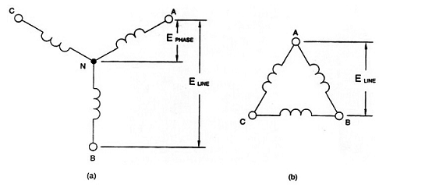

Figure 1. (a) Three phase Wye configuration (b) Three phase Delta configuration

For Wye circuits:

Eline = √3 Ephase and I line = Iphase

For Delta connection:

Eline = Ephase and I line = √3 Iphase

The total active power supplied to a balanced three phase load is:

PT = 3 x P phase = 3 (Ephase x Iphase x cosФ )

The total reactive power supplied to a balanced three phase load is:

QT = 3 x Q phase = 3 (Ephase x Iphase x sinФ )

The total apparent power can be found by using the following formula:

ST = 3 (Ephase x Iphase ) = PT + QT

**Procedure:**

|  |
| --- |
| ***CAUTION***  ***High voltages are present in this laboratory exercise! Do not make or modify any banana jack connections with the power on unless otherwise specified!*** |

* Install the power supply, Data Acquisition Interface (DAI), resistive load, inductive load, capacitive load modules and three phases Squirrel-cage induction motor in the EMS workstation.
* Make sure that the main switch of the power supply is set to the 0 (OFF) position and the voltage control knob is turned fully ccw. Ensure the power supply is connected to a three-phase wall receptacle.
* Ensure that the DAI LOW POWER INPUT is connected to the main power supply and the USB port cable from the computer is connected to the DAI.
* Set the 24V – AC power switch to 1 (ON) position.
* Display the *metering* application. Select setup configuration file *ES16-1.dai.*
* Connect E1, E2 and E3 to measure the line-to-neutral and then the line-to-line variable voltages of the power supply.

In this laboratory exercise, connection diagram will be not provided. You will be required to develop them on your own. Also you have to include the connection diagram in your lab reports.

1. Connect the three-phase power source (EMS8821) to the three phase resistive load (EMS 8311). The load should be Y-connected with a phase to neutral resistance of 1100 Ω. Place the ammeter (DAI ) in series with the load. Measure and record the three line current magnitudes (three load current magnitudes are the same in the Y-connected case). Also measure and record the neutral current, using ammeter.

|  |  |  |
| --- | --- | --- |
| **Quantity** | **Value** | **Units** |
| IA |  |  |
| IB |  |  |
| IC |  |  |
| IN |  |  |

Table 5

Q1) Is the load balanced? State the reason for your answer.

1. Using the resistive load bank (EMS 8311) create a Δ-connected (each R = 1100 Ω). Insert the ammeter in the circuit to measure the line currents. Are the loads equitant? Insert the ammeter to measure the load currents.

|  |  |  |
| --- | --- | --- |
| **Quantity** | **Value** | **Units** |
| IA |  |  |
| IB |  |  |
| IC |  |  |
| IAB |  |  |

Table 6

*Q2) Do the currents obey the expected relationships?*

1. Connect the Voltmeter and ammeter (EMS 9062) between the source and a Y-connected load with each phase consisting of a 1100 Ω resistance in series with a j1100 Ω inductive reactance (EMS 8321). Measure and record the real and reactive power absorbed by the load and the three line current magnitudes.

|  |  |  |
| --- | --- | --- |
| **Quantity** | **Value** | **Units** |
| P3φ |  | W |
| Q3φ |  | VAR |
| IA |  |  |
| IB |  |  |
| IC |  |  |

Table 7

*Q3a) Compute and record the equivalent Y-connected impedance of the load based on the measured quantities.*

ZY = -----------------------------------+ J-------------------------------------Ω

*Q3b) Using the known voltage and load impedance, compute the three phase complex power absorbed by the load.*

*Q3c) Compare your computed result with the measured results (calculate the error percentage).*

1. Replace the inductive reactance with the three-phase capacitive load (EMS 8331) bank at –j1100 Ω. Measure and record the real and reactive power absorbed by the load and line current magnitudes.

|  |  |  |
| --- | --- | --- |
| **Quantity** | **Value** | **Units** |
| P3φ |  | W |
| Q3φ |  | VAR |
| IA |  |  |
| IB |  |  |
| IC |  |  |

Table 8

*Q4a) Compute and record the equivalent Y-connected impedance of the load based on the measured quantities.*

ZY = -----------------------------------+ J-------------------------------------Ω

*Q4b) Using the known voltage and load impedance, compute the three phase complex power absorbed by the load.*

*Q4c) Compare your computed result with the measured one (calculate the error percentage).*

1. Replace the load with Y-connected load in which all three phases contain a series combination of 1100 Ω resistances, a j1100Ω inductive reactance and a –j1100 Ω capacitive reactance. Record the real and reactive powers absorbed by the load. Remove the capacitance and record the real and reactive powers absorbed by the load.

With capacitive load.

|  |  |  |
| --- | --- | --- |
| **Quantity** | **Value** | **Units** |
| P3φ |  | W |
| Q3φ |  | VAR |

Table 9

*Q5a) Explain the results for the reactive power.*

Without capacitive load.

|  |  |  |
| --- | --- | --- |
| **Quantity** | **Value** | **Units** |
| P3φ |  | W |
| Q3φ |  | VAR |

Table 10

*Q5b) Explain the change in the reactive power.*

1. Replace the load with the three-phase squirrel-cage induction motor (EMS 8221) with no mechanical load. Record the real and reactive power delivered to the motor.

|  |  |  |
| --- | --- | --- |
| **Quantity** | **Value** | **Units** |
| P3φ |  | W |
| Q3φ |  | VAR |

Table 11

*Q6) Compute the power factor of the motor.*

# Department of Electrical Engineering

|  |  |
| --- | --- |
| **Faculty Member:____________________** | **Dated: ________________** |
| **Semester:__________________________** | **Section: ________________** |

**EE 260: Electro Mechanical System**

**Lab3: Examples of Faraday's Laws**

|  |  |  |  |  |
| --- | --- | --- | --- | --- |
| **Name** | **Reg. No** | **Report Marks / 10** | **Viva Marks / 5** | **Total/15** |
|  |  |  |  |  |
|  |  |  |  |  |
|  |  |  |  |  |
|  |  |  |  |  |

**Lab3: Examples of Faraday's Laws / P4**

**Objectives:**

**Conduct an experiment:**

* To be able to describe some of the different ways in which a voltage can be induced in a coil.
* To observe that the magnitude of the induced voltage depends upon the rate of change of flux.
* To observe the generation of an ac voltage.
* To observe the saturation curve of a transformer.

**Equipment:**

|  |  |
| --- | --- |
| **Description** | **Model** |
| Variable Resistance | EMS 8311 |
| Mag-Tran parts | EMS 8355 |
| DC Voltmeter/Ammeter | EMS 8412 |
| Power Supply | EMS 8821 |
| Connection Leads | EMS 8941 |
| Oscilloscope | - |

Table 1

The Mag Tran parts you will use are the following:

|  |  |  |
| --- | --- | --- |
| **Qty** | **Description** | Item* |
| 3 | 133 mm Laminated Bar | 1 |
| 1 | 133 mm Laminated Bar with Hook | 3 |
| 1 | 178 mm Laminated Bar | 4 |
| 1 | Mounting Base | 9 |
| 2 | Coil | 10 |
| 1 | Current/Voltage Probe and Rectifier | 11 |
| 1 | BNC/BNC Cable | 12 |
| 1 | Magnet ROd | 16 |

Table 2

*\*Before proceeding, consult Appendix D for the identification of the Mag Tran parts.*

**Discussion:**

Faraday's law states that whenever the voltage inside a coil changes, a voltage is induced across its terminals. The magnitude of the voltage depends upon how fast the flux is changing: the greater the rate of change, the greater is the induced voltage. The magnitude also depends directly upon the number of turns on the coil. Thus, the equation for the induced voltage is:

E= N dФ/dt (1)

where :

E is the induced voltage in Volts.

N is the number of turns on the coil

Ф is the symbol for flux

dФ/dt is the rate of change of flux, in webers per second (Wb/s)

The polarity of the induced voltage depends upon the direction of flux, and whether it is increasing or decreasing inside the coil.

From equation (1) the rate of change of flux inside the coil is given by :

Rate of change of flux dФ/dt= E/N Wb/s (2)

For example if the voltage induced in a 600 turn coil is equal to 12V, then the rate of change of flux is given by dФ/dt= 12/600=0.02 Wb/s

There are several ways in which flux can be made to change inside a coil. In this experiment we shall observe three ways of doing so:

1. Turning on and off the voltage applied to one coil in a magnetic circuit. The flux in the entire magnetic circuit increases immediately after the voltage is turned on, and decreases when the voltage is turned off.

2. Changing the reluctance of the magnetic circuit containing the coil. Reluctance is the 'resistance' of a magnetic path to the flux.

3. Moving a permanent magnet near a coil.

Magnetomotive force (MMF) is the driving force by which a magnetic field is produced. The MMF created when a current flows through a coil is proportional to the current I and the number of turns N in the coil.

MMF= NI

**Procedure:**

1. Set up the circuit as shown in Figure 1. Arrange the 133mm Laminated Bars (Item 1) so that when the screws are tightened , the studs (pointing downwards) are forced into the grooves in the Mounting Bars, locking the bars in place.

**CAUTION**

**High voltages are present in this experiment.**

**Do not make any connections with the power ON.**

**Be sure to connect each ground terminal (green)**

**on the components to the power supply ground.**

The 4400 Ω resistor is used to limit the induced voltage between terminals 3 and 4 of coil A when switch A associated with the 1100 Ω resistor R1 is opened. The 1100 Ω resistor limits the current flowing in the coil when the switch S is closed. On your Variable Resistance, use separate resistance sections for R1 and R2.

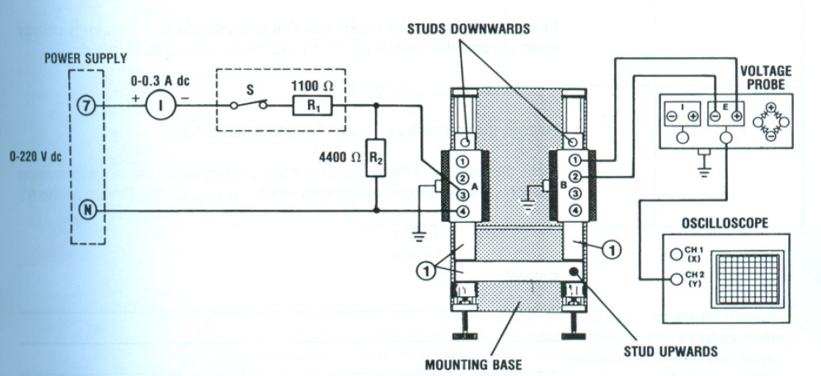

Figure 1. Induction circuit with open magnetic circuit.

Set the oscilloscope so that there is no horizontal sweep (X-Y) mode. This causes the luminous spot to be stationary on the screen. Set the vertical scale to 0.2V/div, DC input mode, and set the spot at the center of the screen. Adjust the intensity control so that the spot is of medium brightness.

On the power supply, turn the main control to 0. Then turn on the power and adjust current I to 30 m A dc.

1. Operate switch S (associated with the 1100Ω resistor), turning it on and off several times. Observe the behavior of the spot on the screen. Each time the switch is opened or closed, it causes a rapid change of flux inside the coils.

Q1) Describe the action of the spot on the oscilloscope display.

_______________________________________________________________

_______________________________________________________________

Observe and note the maximum induced voltage Emax and its polarity upon opening the switch (current I decreases from 30 mA to 0 mA dc).

**Note:** The sensitivity of the voltage probe is 100 mV/V. For this reason, all voltage readings made using the voltage probe must be multiplied by 10.

Emax= ____________________ V

Record these results in Table 3. (Assembly A.)

Q2) Does the polarity of the induced voltage change when the flux is increasing (switch closed), as compared with when its decreasing (switch opened)?

Yes No

Explain.

_______________________________________________________________

_______________________________________________________________

Turn off the power, and set the oscilloscope to produce a horizontal sweep to protect the screen.

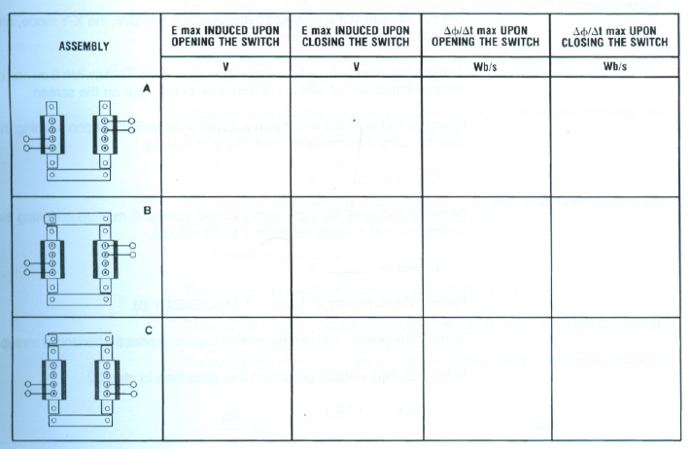

Table 3.

1. Referring to step 2, and using equation 2, calculate the maximum rate of change of flux, dФ/dt, when current I decreases from 30 to 0 mA dc. The number of turns (N) of the coil is 600 between terminals 1 and 2.

dФ/dt max = Emax/N= ______=_________Wb/s

Calculate the maximum rate of change of flux when current I increases from 0 to 30 mA dc.

dФ/dt max = Emax/N= ______=_________Wb/s

Record these results in Table 3. (Assembly A.)

1. Set up the assembly as in Figure 2. Use the 133mm Laminated Bar with Hook (Item 3). Tighten the screws in order to minimize the air gaps in the magnetic circuit. Note that the upper bar presses against the rubber stops. Because the magnetic circuit in Figure 2 is closed, the reluctance of this magnetic circuit is much smaller than in Figure 1.Consequently a larger flux is produced in the iron core (and inside the coils).

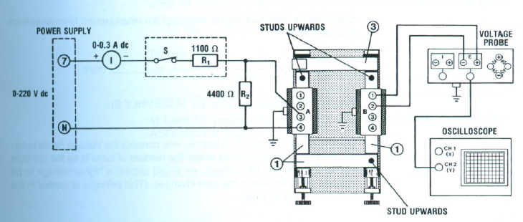

Figure 2. Induction circuit with closed magnetic circuit.

Set the vertical scale of the oscilloscope to 0.5 V/DIV, the X-Y mode, and the spot at the center of the screen.

Turn on the power and adjust current I to 30 mA. Turn switch S on and off several times and observe the behavior of the spot on the screen.

Observe and note the maximum induced voltage E max upon opening the switch (current I decreases from 0 to 30 mA dc).

E max = ___________ V

Observe and note the maximum induced voltage E max upon closing the switch (current I increases from 0 to 30 mA dc).

E max = ___________ V

Record these results in Table 3 (Assembly B).

Turn off the power, and set the oscilloscope to produce a horizontal sweep.

Q3) Is the produced voltage greater in this step than in step 2?

Yes No

Explain.

_______________________________________________________________

_______________________________________________________________

Calculate the maximum rate of change of flux, dФ/dt max, when current I decreases from 0 to 30 mA dc.

dФ/dt max = Emax/N= ______=_________Wb/s

Calculate the maximum rate of change of flux, dФ/dt max, when current I increases from 0 to 30 mA dc.

dФ/dt max = Emax/N= ______=_________Wb/s

Record these results in Table 3. (ASSEMBLY B).

1. Use the circuit of Figure 2, but this time connect the Voltage Probe to terminals 3 and 4 of coil B. This raises the number of turns N on the coil from 600 to 2400 turns. As a result we would expect a higher voltage to be induced when the flux in the core changes. (This system is applied in the ignition system of cars.)

Set the vertical scale of the oscilloscope to 2V/DIV, the X-Y mode, and the spot at the center of the screen.

Turn on the power and adjust current I to 30 mA dc. Turn switch S on and off several times and observe the behavior of the spot on the screen.

Observe and note the maximum induced voltage E max upon opening the switch (current I decreases from 0 to 30 mA dc).

E max = ___________ V

Observe and note the maximum induced voltage E max upon closing the switch (current I increases from 0 to 30 mA dc).

E max = ___________ V

Record these results in Table 3 (Assembly C).

Turn off the power, and set the oscilloscope to produce a horizontal sweep.

Calculate the maximum rate of change of flux, dФ/dt max, when current I decreases from 0 to 30 mA dc.

dФ/dt max = Emax/N= ______=_________Wb/s

Calculate the maximum rate of change of flux, dФ/dt max, when current I increases from 0 to 30 mA dc.

dФ/dt max = Emax/N= ______=_________Wb/s

Record these results in Table 3. (ASSEMBLY C).

Q4) Does the induced voltage depend upon the number of turns on the coil?

Yes No

Explain.

_______________________________________________________________

_______________________________________________________________

Q5) In Table 3, compare the maximum voltages for ASSEMBLY C to that for ASSEMBLY B. Explain the differences, if any.

_______________________________________________________________

_______________________________________________________________

1. The amount of flux inside a coil depends upon the reluctances of the magnetic circuit. In Figure 3, the dc current in coil A is kept constant at 30 mA dc, but we will move the long iron bar (Item 4) back and forth so that the air gaps in the magnetic circuit increase and decrease. When the gap increases, the reluctance of the magnetic circuit increases, causing the flux in coil B to decrease. The change in flux causes a voltage to be induced in coil B. Conversely, when the gap decreases, the flux increases, again inducing a voltage in coil B, but of opposite polarity.

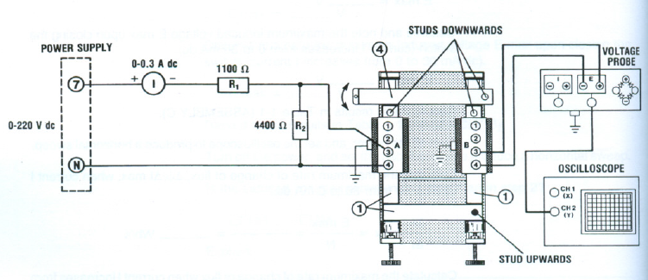

Figure 3. Variable reluctance magnetic circuit.

Set up the circuit of Figure 3. Tighten the screws so that all short bars are locked in place. Set the vertical scale of the oscilloscope to 1 V/DIV, the X-Y mode, and the spot at the center of the screen.

Turn on the power and adjust current I to 30 mA dc.

Swing one end of the long bar, so that it pivots around the stud on the other end as shown in Figure 3.

Swing the bar quickly away from its closed position. Observe the maximum induced voltage E max, measure by the oscilloscope.

E max = ___________ V

Bring the long bar quickly back to its original position. Observe the maximum induced voltage E max.

E max = ___________ V

Turn off the power, and set the oscilloscope to produce a horizontal sweep.

Calculate the maximum rate of change of flux, dФ/dt max, when the long bar is pulled away.

dФ/dt max = Emax/N= ______=_________Wb/s

Calculate the maximum rate of change of flux, dФ/dt max, when the long bar is brought back to its closed position.

dФ/dt max = Emax/N= ______=_________Wb/s

1. We shall now use the Magnet Rod to generate an alternating voltage. Set the oscilloscope to 10 mV/DIV and the sweep to 0.1 s/DIV. Swing one end of the Magnet Rod between the two vertical bars with a constant rocking motion, as shown in Figure 4.

Q6) Describe the waveform of the induced voltage.

_______________________________________________________________

_______________________________________________________________

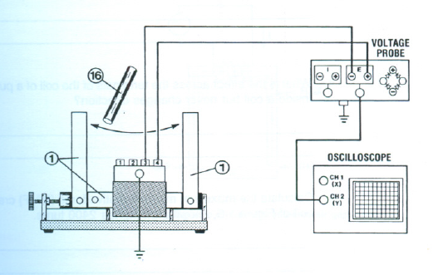

Figure 4. Circuit used to generate an alternating voltage with the use of a magnet.

1. Set up the circuit as shown in Figure 5. Arrange the laminated bars and tighten the screws in order to reduce the air gaps in the magnetic circuit as much as possible.

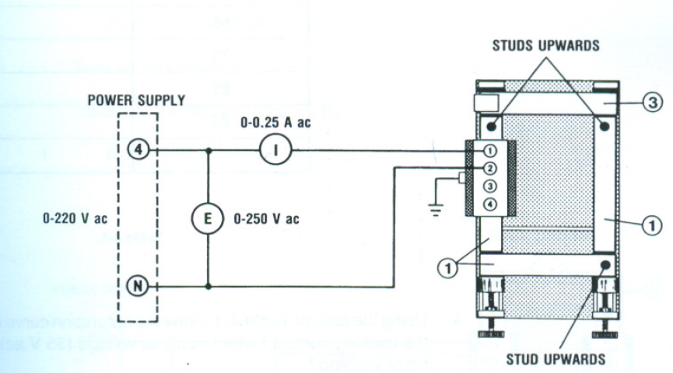

Figure 5. Saturation curve circuit.

1. On the power supply, turn the main control to 0. Then turn on the power and adjust voltage E to 50 V ac. If the core vibrates strongly, tighten the clamping screws. Check the value of the exciting current I. It should be between 0.15 A ac and approximately 0.25 A ac. If it is much greater than 0.25 A ac, try tightening the screws some more, or slightly rearranging the laminated bars to minimize the air gaps.
2. Without making any other changes to your set up, reduce the primary voltage to 0 V and then gradually increase it using the values given in Table 4. Record the corresponding values of the exciting current. Determine also the primary voltage required to obtain an exciting current of 1 A ac.

Note: You will have to change the scale on the AC ammeter. Before doing so, be sure to turn off the power.

Turn off the power.

|  |  |
| --- | --- |
| Primary Voltage | Exciting Current |
| V ac | A ac |
| 15 |  |
| 25 |  |
| 35 |  |
| 45 |  |
| 55 |  |
| 65 |  |
| 75 |  |
| 85 |  |
| 95 |  |
|  |  |

Table 4.

Using the data of Table 4, draw and label the saturation curve in Figure 6.

Q7) What is the exciting current I when nominal voltage (55 V ac) is applied to the primary winding.

I = ____________ A ac

|  |  |  |  |  |  |  |  |  |  |  |  |  |  |  |
| --- | --- | --- | --- | --- | --- | --- | --- | --- | --- | --- | --- | --- | --- | --- |
|  |  |  |  |  |  |  |  |  |  |  |  |  |  |  |
|  |  |  |  |  |  |  |  |  |  |  |  |  |  |  |
|  |  |  |  |  |  |  |  |  |  |  |  |  |  |  |
|  |  |  |  |  |  |  |  |  |  |  |  |  |  |  |
|  |  |  |  |  |  |  |  |  |  |  |  |  |  |  |
|  |  |  |  |  |  |  |  |  |  |  |  |  |  |  |
|  |  |  |  |  |  |  |  |  |  |  |  |  |  |  |
|  |  |  |  |  |  |  |  |  |  |  |  |  |  |  |
|  |  |  |  |  |  |  |  |  |  |  |  |  |  |  |
|  |  |  |  |  |  |  |  |  |  |  |  |  |  |  |
|  |  |  |  |  |  |  |  |  |  |  |  |  |  |  |
|  |  |  |  |  |  |  |  |  |  |  |  |  |  |  |
|  |  |  |  |  |  |  |  |  |  |  |  |  |  |  |

Figure 6. Saturation Curve

# 

# Department of Electrical Engineering

|  |  |
| --- | --- |
| **Faculty Member:____________________** | **Dated: ___________________** |
| **Semester:__________________________** | **Section: __________________** |

**EE 260: Electro Mechanical System**

**Lab4: Eddy Currents and Laminated Cores**

|  |  |  |  |  |
| --- | --- | --- | --- | --- |
| **Name** | **Reg. No** | **Report Marks / 10** | **Viva Marks / 5** | **Total/15** |
|  |  |  |  |  |
|  |  |  |  |  |
|  |  |  |  |  |
|  |  |  |  |  |

**Lab4: Eddy Currents and Laminated Cores / P4**

**Objectives:**

**Conduct an experiment:**

* To demonstrate eddy currents.
* To observe the beneficial effect of using laminated iron cores.
* To observe Lenz's law experimentally.

**Equipment:**

|  |  |
| --- | --- |
| **Description** | **Model** |
| Mag-Tran parts | EMS 8355 |
| AC Ammeter | EMS 8425 |
| AC Voltmeter | EMS 8426 |
| Connection Leads | EMS 8941 |
| Power Supply | EMS 8821 |

Table 1

The Mag Tran parts you will use are the following:

|  |  |  |
| --- | --- | --- |
| **Qty** | **Description** | **Item\*** |
| 3 | 133 mm Laminated Bar | 1 |
| 1 | 133 mm Laminated Bar with Hook | 3 |
| 1 | 178 mm Laminated Bar | 4 |
| 1 | 133mm Steel Bar | 6 |
| 1 | Mounting Base | 9 |
| 1 | Coil | 10 |
| 1 | Aluminum Ring | 18 |

Table 2

*\*Before proceeding , consult Appendix D for the identification of the Mag Tran parts.*

**Discussion:**

An alternating magnetic field is always surrounded by an alternating electric field, as shown in Figure 1. This is the basis of Faraday's law of electromagnetic induction. If an electron happens to be in the alternating electric field, it will move first in one direction, then in the other, following the lines of force of the electric field.

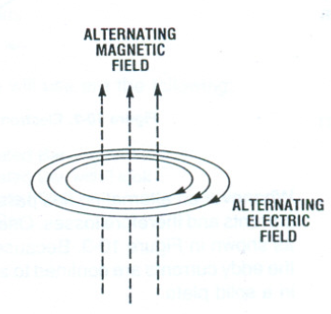

Figure 1. Relationship between magnetic and electric fields.

If the alternating magnetic field goes through a metallic plate, as shown in Figure 2, the alternating electric field will act on the free electrons inside the plate, causing them to oscillate back and forth. But, any electron flow is actually an electric current. It follows that an alternating current flows in the plate, causing it to heat up. The current follows a circular path, flowing back and forth throughout the whole body of the plate. It moves in the same way that water in a bucket swishes back and forth when it is stirred one way, then the other. That is why the current in the plate is called an eddy current. It is also called Foucault current.

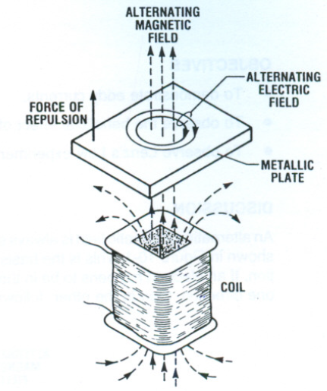

Figure 2. Electromagnetic induction in a metallic plate.

Whenever an alternating flux passes through a solid metal plate, it produces eddy currents and therefore losses. One way to reduce the losses is to laminate the plate as shown in Figure 3.

Because the laminations are insulated from each other, the eddy currents are confined to smaller area, and so they are much smaller than in a solid plate.

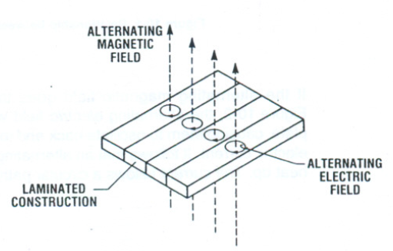

Figure 3. Electromagnetic induction in a laminated construction.

It is particularly important to laminate the iron core of a transformer, because it carries a large alternating magnetic flux. Most transformer laminations are about 0.35 mm thick and they are covered with a very thin varnish or oxide insulation.

For the same reason, the iron cores of ac motors and generators have to be laminated.

According to Lenz's Law, eddy currents in a metallic object flow in such a direction as to oppose the change of flux through the object. As a result, the magnetic field created by the eddy currents acts in opposition to the magnetic field that produced the eddy currents in the first place. In Figure 2 this produces a force of repulsion between the object and the coil that creates the flux. Thus the object tends to push away from the flux-producing coil. We will observe this phenomenon in this experiment.

**Procedure:**

1. Set up the circuit as shown in Figure 4. Tighten the screws in order to minimize the air gaps in the magnetic circuit.

**CAUTION**

**High voltages are present in this experiment.**

**Do not make any connections with the power ON.**

**Be sure to connect each ground terminal (green)**

**on the components to the power supply ground.**

1. Turn on the power and adjust voltage E to 55 V ac. Measure the value of current I and keep the circuit in operation for 5 minutes. At the end of this period, again measure the value of current I and observe the temperature of the four bars, by hand. State whether the temperature is cool, slightly warm, or hot.

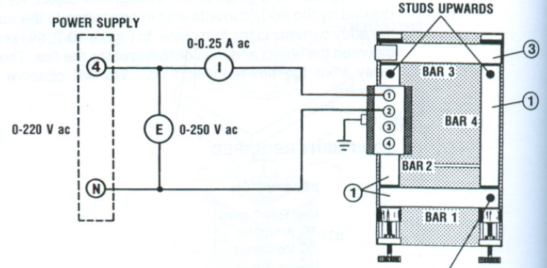

Figure 4. Circuit used for the observation of the effects of a laminated construction on electromagnetic induction.

Complete Table 3.

Turn off the power.

|  |  |  |  |  |  |  |
| --- | --- | --- | --- | --- | --- | --- |
| **TIME** | **E** | **I** | **TEMPERATURE** | | | |
| min | V ac | A ac | BAR1 | BAR2 | BAR3 | BAR4 |
| 0 | 55 |  |  |  |  |  |
| 5 | 55 |  |  |  |  |  |

Table 3.

1. Set up the circuit of Figure 5 using the 133 mm solid soft Steel Bar (Item 6) instead of a laminated bar. Tighten the screws in order to minimize the air gaps in the magnetic circuit.
2. Turn on the power and adjust voltage E to 55 V ac. Measure the value of the current I and keep the circuit in operation for 5 minutes. At the end of this period, again measure the value of the current I and observe the temperature of the bars, by hand. State whether the temperature is hot, slightly warm, or hot.

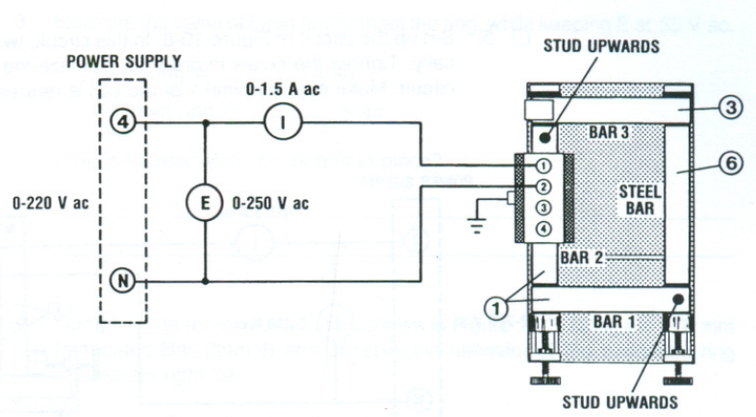

Figure 5. Circuit used to observe the effect of a solid steel bar on electromagnetic induction.

Complete Table 4.

Turn off the power.

|  |  |  |  |  |  |  |
| --- | --- | --- | --- | --- | --- | --- |
| **TIME** | **E** | **I** | **TEMPERATURE** | | | |
| min | V ac | A ac | BAR1 | BAR2 | BAR3 | BAR4 |
| 0 | 55 |  |  |  |  |  |
| 5 | 55 |  |  |  |  |  |

Table 4.

Q1) After the 5-minute test, explain any difference in the temperature of the bars.

____________________________________________________________

____________________________________________________________

____________________________________________________________

Q2)Why is the exciting current much greater in this step than in step 2?

____________________________________________________________

____________________________________________________________

____________________________________________________________

1. Set up the circuit of Figure 6. In this circuit, two bars are mounted vertically. Tighten the screws in order to minimize the air gaps in the magnetic circuit. Make sure terminal 1 of the coil is nearest the left bar, as shown.

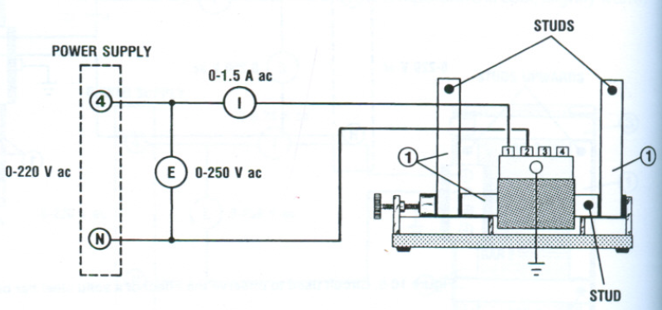

Figure 6. Circuit used to measure the effects of eddy currents in a metallic ring.

1. Turn on the power and adjust voltage E to 55V ac. Measure the value of I.

I= _____________ A ac.

Q3) Why is I greater now than it was in step 2?

_______________________________________________________________

_______________________________________________________________

1. Place the Aluminum ring (Item 18) over the right bar and observe what happens. Describe what happens.

**CAUTION**

**The aluminum ring can become *very* hot.**

Let the ring float for about 1 minute and observe that it becomes quite hot. Q4)Why does it heat up?

_______________________________________________________________

_______________________________________________________________

1. Measure the value of I with and without the ring, while keeping E at 55 V ac.

I with ring= __________________ A ac

I without ring= __________________ A ac

Q5)Why is I larger when the ring is in place?

_______________________________________________________________

_______________________________________________________________

1. Complete the magnetic circuit as shown in Figure 7, using the 178 mm Laminated Bar (Item 4) and observe the behavior of the aluminum ring around the right bar.

Q6)Describe what happens to the ring.

_______________________________________________________________

_______________________________________________________________

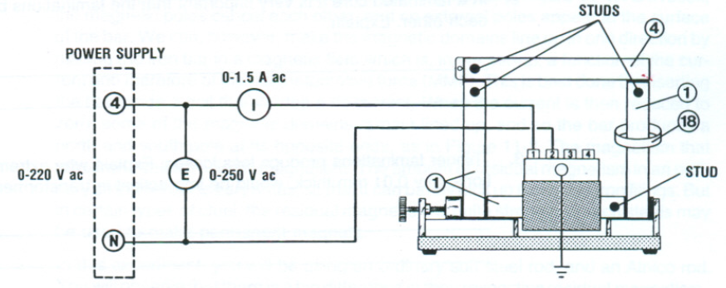

Figure 7. Circuit used to observe the effects of eddy currents in a metallic ring.

1. Open the magnetic circuit by removing the 178 mm Laminated bar (Item 4) for a moment place the ring over the bar, then close the magnetic circuit. Observe what happens.

Q7)Is there a force of repulsion or attraction between the ring and the coil?

**Note:**  Because of the way the coil is wound, the force in this step will be relatively weak.

_______________________________________________________________

_______________________________________________________________

# Department of Electrical Engineering

|  |  |
| --- | --- |
| **Faculty Member:____________________** | **Dated: ________________** |
| **Semester:__________________________** | **Section: ________________** |

**EE 260: Electro Mechanical System**

**Lab5: Hysteresis Loop and Core Losses**

|  |  |  |  |  |
| --- | --- | --- | --- | --- |
| **Name** | **Reg. No** | **Report Marks / 10** | **Viva Marks / 5** | **Total/15** |
|  |  |  |  |  |
|  |  |  |  |  |
|  |  |  |  |  |
|  |  |  |  |  |

**Lab5: Hysteresis Loop and Core Losses / P4**

**Objectives:**

**Conduct an experiment:**

* To learn how to use a flux meter.
* To display a dynamic hysteresis loop on the oscilloscope.
* To measure the core losses in a laminated core.
* To measure the core losses in a solid steel core.
* To compare the core losses in different cores.
* To display excitation current of a core on a virtual oscilloscope.

**Equipment:**

|  |  |
| --- | --- |
| **Description** | **Model** |
| Transformer | EMS 8341 |
| Mag-Tran parts | EMS 8355 |
| Flux Meter | EMS 8463 |
| AC Voltmeter | EMS 8426 |
| Connection Leads | EMS 8941 |
| Power Supply | EMS 8821 |
| Oscilloscope | - |

Table 1

The Mag Tran parts you will use are the following:

|  |  |  |
| --- | --- | --- |
| **Qty** | **Description** | Item* |
| 3 | 133 mm Laminated Bar | 1 |
| 1 | 133 mm Laminated Bar with Hook | 3 |
| 1 | 133mm Steel Bar | 6 |
| 1 | Mounting Base | 9 |
| 1 | Coil | 10 |
| 1 | Current/Voltage Probe and Rectifier | 11 |
| 1 | BNC/BNC Cable | 12 |

Table 2

*\*Before proceeding , consult Appendix D for the identification of the Mag Tran parts.*

**Discussion:**

Consider a coil having N turns connected to an ac source E. It draws and ac current which produces an alternating flux ϕ in an iron core (see Figure 1). If the instantaneous flux ϕ is plotted against the instantaneous current I, we obtain a closed loop whose general shape is shown in Figure 2. This is called a dynamic hysteresis loop.

The hysteresis loop shows two values of the flux for each value of the current; one when the current is increasing, the other when it is decreasing.

**Note:** Usually this type of loop represents the variations of the magnetic flux density B against the magnetic field strength. H.

The hysteresis loop is usually formed by static magnetization curves. However, this term may also be loosely used to refer to the loop formed by dynamic magnetization curves.

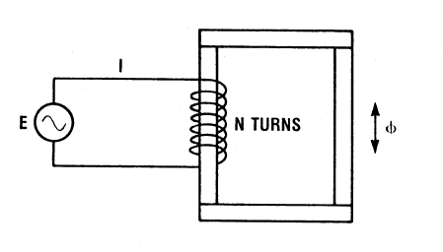

Figure 1. AC Source connected to a coil of N turns.

This type of hysteresis loop gives an indication of the core loss (also called iron loss). This loss is composed of both the hysteresis loss and the eddy current loss in the iron core. It can be shown that the area of the loop (in Weber-Amperes) is equal to the core loss in joules per cycle per turn of the coil. Therefore the total core loss, PL is given by the equation:

**PL=ANf**

Where

PL is the total core loss, in watts

A is the area of the hysteresis loop, in Wb-A

N is the number of turns on the coil that produces the flux

F is the frequency of the source, in hertz

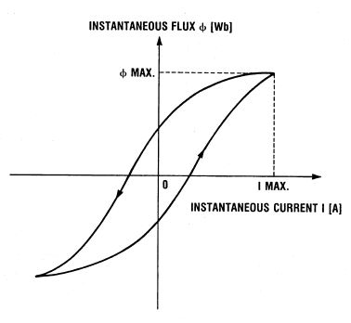

Figure 2. Hysteresis Loop.

The hysteresis loop can be displayed in the screen of the oscilloscope provided that the current I and the flux ϕ are first converted into equivalent instantaneous voltages. This can be done using the current probe and the flux meter. In the current probe, the current is transduced into a voltage V1 by placing a resistance R in series with the winding. The value of R is sufficiently small so that the IR drop is negligible compared with the supply voltage E (see Figure 3). A search coil S is used with the flux meter to sample the flux and a special integrating circuit T in the flux meter makes the output voltage V2 proportional to the instantaneous flux. Voltage V1 is applied to the horizontal axis (X) and voltage V2 is applied to the vertical (Y) axis of the oscilloscope. The area of the resulting loop can be measured by photographing it or by copying it using tracing paper.

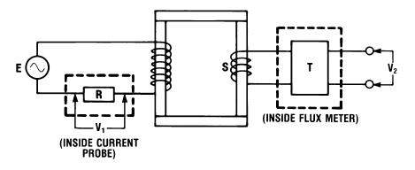

Figure 3. Using the current probe and the flux meter.

The Lab-Volt Flux Meter has a PROBE INPUT for the search coil to measure the flux. The output (Instantaneous flux output) gives a voltage proportional to the instantaneous flux. Note that the current probe must be connected as shown in Figure 4, using a transformer for isolation from the power supply.

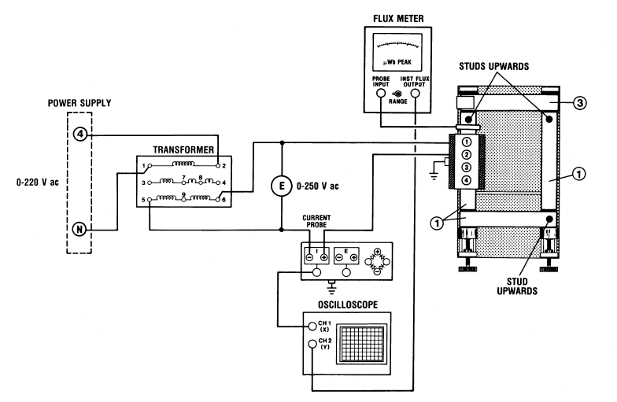

Figure 4. Circuit used to observe the hysteresis loop.

It should be noted that in the hysteresis loop obtained in this exercise, the intercept on the horizontal axis is not a measure of the coercive force and the intercept on the vertical axis is not a measure of the remnant magnetism as in a regular hysteresis loop.

**Procedure:**

1. Set up the circuit as shown in Figure 4. Tighten the screws in order to minimize the air gaps. Set the oscilloscope to DC input mode and the X-Y mode. Select the 0-1000 µWb peak scale on the flux meter.

In Table 3, calculate the theoretical values of the ϕ max using the formula:

Φmax= E/(4.44 fN).

**CAUTION**

**High voltages are present in this experiment.**

**Do not make any connections with the power ON.**

**Be sure to connect each ground terminal (green)**

**on the components to the power supply ground.**

1. Apply power and raise voltage E gradually until it is equal to 55Vac. Observe the display on the oscilloscope. If the loop is reversed from that shown in Figure 2, turn off the power and turn the search coil.

Apply voltage E to each value shown in Table 3. For each value of E, measure both V1 max (X-axis on the oscilloscope display) and V2 max (Y-axis). Then calculate the corresponding maximum values of current I and flux ϕ. Note that the sensitivity of the current probe is 100 mV/A, and that the sensitivity of the flux meter (instantaneous flux output) is 1 mV/µW.

Therefore:

I max (A) = V1 max (mV)/100

Φ max (µWb) = V2 max (mV)

.

|  |  |  |  |  |  |
| --- | --- | --- | --- | --- | --- |
| **E** | **Φ max\*** | **V1 max** | **V2 max** | **I max \*** | **Φ max\*\*** |
| V ac | µWb | mV | mV | A | µWb |
| 20 |  |  |  |  |  |
| 40 |  |  |  |  |  |
| 60 |  |  |  |  |  |
| 80 |  |  |  |  |  |
| 85 |  |  |  |  |  |

Table 3

* *Theoretical Value*

*\*\* Measured Value*

Q1) Compare the measured values of the flux ϕ max with the theoretical values.

_______________________________________________________________

_______________________________________________________________

_______________________________________________________________

Q2) How do the current I max and the flux ϕ max change as the applied voltage E increases?

_______________________________________________________________

_______________________________________________________________

_______________________________________________________________

1. Observe how the hysteresis loop changes shape as voltage E is varied. Note that its area increases with increasing voltage.

Q3) What does this indicate about the change in core loss as the flux increases?

_______________________________________________________________

_______________________________________________________________

_______________________________________________________________

1. Using Figure 5, copy the hysteresis loop displayed on the screen, when E=10V. The best way to do this is to select a few X-Y coordinates on the oscilloscope display and transcribe them onto Figure 5.

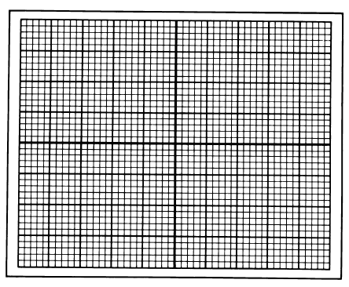

Figure 5.

1. Calculate the area of the loop in V2 , using the following procedure:

Q4a) Number of square divisions in the loop= _______

(Count the number of small squares inside the loop, and divide by 25.)

Q4b)Area of each square division = X-scale on the oscilloscope x Y-scale

= __________ V/DIV x ___________ V/DIV

=___________ V2/DIV2

Q4c) Area of loop = number of square divisions x area of each square division

Area of loop = ____________ V2

Q4d) Calculate the area A of the loop in weber-amperes:

A= Area of loop in V2 / (sensitivity of current probe in V/A x sensitivity of flux meter in V/Wb)

A= Area of loop in V2 / (0.1 V/A x 1000 V/Wb)

A=________ Wb.A

Q4e) Calculate the core loss:

Number of turns on coil A, N=________

Frequency of the source, f=__________ Hz

Core loss, PL=ANf=__________W

1. Using a short lead, loop it around the bar without the coil and short-circuit the lead on itself. Observe that the hysteresis loop becomes broader.

Turn off the power.

1. Replace the right laminated bar without coil in Figure 4 by the solid soft Steel Bar (Item 16).
2. Apply power and raise the voltage E to 10V. Observe the display on the oscilloscope. Measure V1 max and V2 max and calculate the corresponding maximum values of I max and flux ϕ max.

Q5) Fill in the following details:

V1 max = ________ V

V2 max = ________ V

I max = _________ A

Φ max = ________ µWb

1. Using Figure 6, copy the hysteresis loop when E=10 V.



Figure 6.

1. Calculate the core loss, using the same procedure as outlined in step 5. Q6)PL=__________W

Turn off the power.

Q7)Why is core loss in step 10 much greater than that in step 5?

_______________________________________________________________

_______________________________________________________________

1. Set up the circuit as shown in Figure 7. In order to better compare the excitation current waveform in a transformer with that of a resistor, connect simultaneously the same circuit as shown in Figure 7 but for a resistive load. Effectively, that means you are connecting leads going to 1 and 2 terminals of the coil, to a resistor (R= 1100 Ω) .

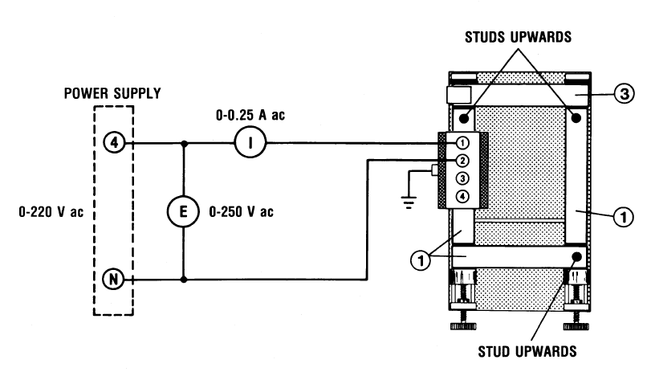

Figure 7. Circuit used to display excitation current on virtual scope.

For about a minute only, turn on the power till E= 110 V.

Display the waveforms of both current meters (one for the coil, one for the resistor) on a virtual scope (LVDAC-EMS).

Q8) Take a screen shot of the display on the scope with both current waveforms displayed simultaneously.

Turn off the power.

# Department of Electrical Engineering

|  |  |
| --- | --- |
| **Faculty Member:____________________** | **Dated: ________________** |
| **Semester:__________________________** | **Section: ________________** |

**EE 260: Electro Mechanical System**

**Lab6: Single Phase Transformers**

|  |  |  |  |  |
| --- | --- | --- | --- | --- |
| **Name** | **Reg. No** | **Report Marks / 10** | **Viva Marks / 5** | **Total/15** |
|  |  |  |  |  |
|  |  |  |  |  |
|  |  |  |  |  |
|  |  |  |  |  |

**Lab6: Single Phase Transformers / P4**

**Objectives:**

**Conduct an experiment:**

* To determine the polarity of a transformer using a dc source.
* To determine the polarity of a transformer using an ac source.
* To determine the current ratio of a transformer.
* To determine the impedance of a transformer.
* To perform open circuit and short circuit test to evaluate transformer equivalent circuit parameters.
* To observe the voltage regulation of a transformer for resistive, inductive and capacitive loads.

**Equipment:**

|  |  |
| --- | --- |
| **Description** | **Model** |
| Three phase transformer bank | EMS 8348 |
| Three phase inductive load | EMS 8321 |
| Variable Resistance | EMS 8311 |
| Mag-Tran parts | EMS 8355 |
| Three phase WATT/VAR meter | EMS 8446 |
| DC Voltmeter/Ammeter | EMS 8412 |
| AC Voltmeter | EMS 8426 |
| AC Ammeter | EMS 8425 |
| Power Supply | EMS 8821 |
| Connection Leads | EMS 8941 |

Table 1

The Mag Tran parts you will use are the following:

|  |  |  |
| --- | --- | --- |
| **Qty** | **Description** | **Item\*** |
| 3 | 133 mm Laminated Bar | 1 |
| 1 | 133 mm Laminated Bar with Hook | 3 |
| 1 | Mounting Base | 9 |
| 2 | Coil | 10 |

Table 2

*\*Before proceeding, consult Appendix D for the identification of the Mag Tran parts.*

**Discussion:**

**Polarity of a Transformer:**

The primary and secondary voltages of a transformer increase and decrease in steps reaching their maximum values at practically the same instant. Because the voltages are alternating, the polarity of the terminals is continually changing. In Figure 1, because of the ac source Es, the

terminal 1 is momentarily positive with respect to terminal 2, and an instant later its polarity is reversed. The same is true for the polarity of terminal 3 with respect to terminal 4.

The ‘polarity’ of a transformer tells us which terminals of the transformer are positive at the same instant. For example, when terminal 1 in Figure 1 is momentarily positive with respect to terminal 2, the polarity of the transformer indicates whether terminal 3 is momentarily positive or negative with respect to terminal 4.

One quick way to determine the polarity is to momentarily connect the primary winding P to a dc source, as shown in Figure 2. This causes a momentary current to flow in primary winding P so a flux is created in the core. The change in flux induces a momentary voltage across terminals 3 and 4 whose polarity can be found by means of a dc voltmeter E.

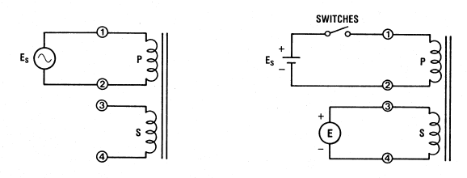

Figure 1. Transformer. Figure 2. Circuit used to determine the transformer polarity using a dc source.

In Figure 2, terminal 3 is connected to the positive terminal of the voltmeter, and terminal 1 is connected to the positive side of the dc source. When the switch is closed, terminal 1 becomes positive with respect to terminal 2. If at the same time the pointer on the voltmeter E moves upscale, it shows that terminal 3 is positive with terminal 4. In this case, we can state that the polarity of the transformer is such that terminal 1 is positive with respect to 2 at the same instant as terminal 3 is positive with respect to 4.

If the pointer shows a negative reading when the switch is closed, the terminal 3 is negative with respect to 4. In this case, the polarity of the transformer is such that 4 is positive with respect to 3 when terminal 1 is positive with respect to 2.

If a dc source is not available, the polarity of a transformer can be found by connecting one of the windings (usually the high voltage (H.V.) winding) to an ac source. The other winding is then connected in series with the first winding and the total series voltage across both windings is compared with the voltage across the first winding. The result enables us to state the polarity of the transformer.

For example, consider windings P and S, with S (the H.V. winding) connected to an ac source Es (see Figure 3). The second winding P is connected in series with S by means of a jumper

between terminals 2 and 3. An ac voltmeter E measures the series voltage. In this test, if E is greater than Es, the terminals that are joined together have opposite polarities. This means that when terminal 2 is positive with respect to 1, terminal 3 is negative with respect to 4.

If E is less than Es, the terminals that are connected together have the same instantaneous polarity. Therefore when terminal 2 is positive with respect to 1, terminal 3 is positive with respect to terminal 4.

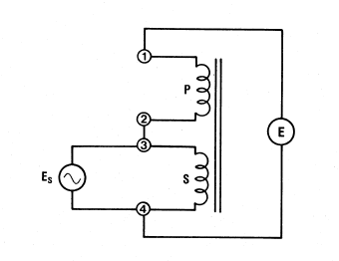

Figure 3. Circuit used to measure the polarity of the transformer using an ac source.

**Current Ratio and Impedance of a Transformer**

When the primary winding of an ideal transformer is connected to an ac source and the secondary winding is connected to a load, the ratio of the primary current I1 to secondary current I2 is given by the equation:

I1/I2 = N2/N1

where:

N1 is the number of primary turns

N2 is the number of secondary turns

In practice, the ratio I1/I2 is not exactly to the turns ratio because of the exciting current that is drawn by the primary winding.

One of the easiest ways to measure the current ratio is to short-circuit the secondary winding, and apply a relatively low ac voltage E1 should be small enough so that current I1 is no greater than the nominal current of the primary winding. This prevents overheating of the windings.

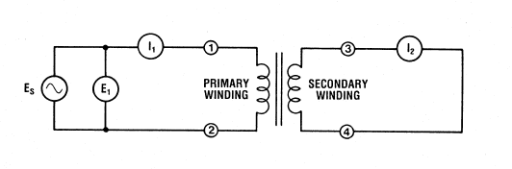

Figure 4. Circuit used to measure the current ratio.

A practical transformer can be represented as an ideal transformer with a resistance R and a reactance connected in series with each of the windings, as shown in Figure 5.

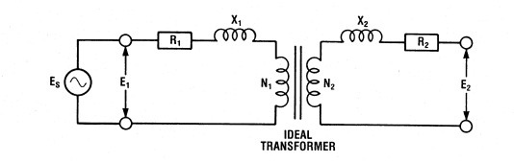

Figure 5. Equivalent circuit of a transformer

Since a transformer can transform impedances, the resistance and reactance of one winding in the equivalent circuit can be transferred, or referred, to the other winding by multiplying their value by the square of the turns ratio. Figure 6 shows the same equivalent circuit as in Figure 7, but with all the impedances referred to the primary winding.

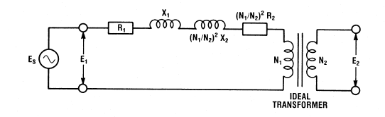

Figure 6. Equivalent circuit with all impedances referred to the primary winding.

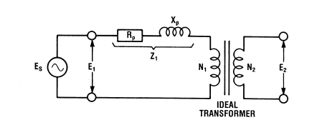

Figure 7. Equivalent circuit of a transformer.

**Open Circuit Test:**

The rated voltage is applied to the primary side. Then voltage, current and power is measured.

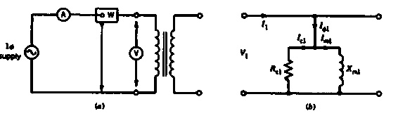

Figure 8. Open Circuit Test







**Short Circuit Test:**

The input voltage is adjusted until the current in the short circuited windings is equal to its rated value.

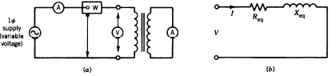

Figure 9. Short Circuit Test.







**Voltage Regulation**

Compares the output voltage of the transformer at no load with the output voltage at full load





The transformer efficiency can be computed by:

η = (Pin – Core loss – Copper loss)/Pin

**Procedure:**

1. Set up the circuit as shown in Figure 10. Make sure coils A and B are similarly placed on the laminated bars; for example, terminals 4 f each coil nearest to you. Tighten the screws in order to minimize the air gaps in the magnetic circuits. Be sure terminal 1 is connected to the positive side of the power supply when S is closed. (S is the switch associated with the 1100 Ω resistor). Be sure terminal 3 is connected to the positive side of the DC Voltmeter.

**CAUTION**

**High voltages are present in this experiment.**

**Do not make any connections with the power ON.**

**Be sure to connect each ground terminal (green)**

**on the components to the power supply ground.**

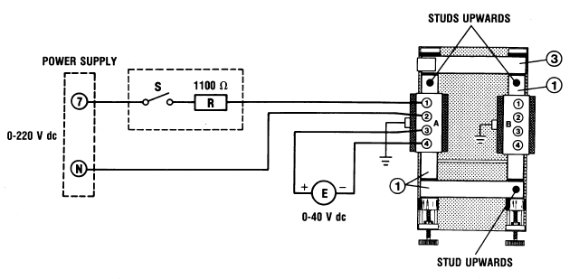

Figure 10. DC circuit used to determine the polarity of a transformer.

1. Set the voltmeter switch on the power supply to position 7-N. Turn on the power. Observing the voltmeter on the power supply, set the voltage to 100 V dc. Turn switch S on and off several times.

Q1) On closing the switch, answer the following questions.

a) Does the pointer of voltmeter E move upscale?

Yes No

b) What is the instantaneous polarity of terminal 3 with respect to terminal 4?

Positive Negative

c) What is the instantaneous polarity of terminal 1 with respect to terminal 2?

Positive Negative

d) Which of the following terminals are positive at the same time?

1 and 3 1 and 4

Turn off the power.

1. Keep the circuit of Figure 10 but connect the DC Voltmeter E to terminals 3 and 4 of the coil B. Be sure terminal 3 is connected to the positive side of the DC Voltmeter.
2. Turn on the power. Using the meter on the power supply (position 7-N), set the voltage to 100 V dc. Turn switch S on and off several times.

Q2) On closing the switch, answer the following questions.

a) Does the pointer of voltmeter E move upscale?

Yes No

b) What is the instantaneous polarity of terminal 3 with respect terminal 4?

Positive Negative

c) What is the instantaneous polarity of terminal 1 of coil A with respect to terminal 2?

Positive Negative

d) Which of the following terminals are positive at the same time?

1 and 3 1 and 4

Although the coils A and B are identical, why is the polarity in this step not the same as that in step 2?

_______________________________________________________________

______________________________________________________________________________________________________________________________

Turn off the power.

1. Set up the circuit of Figure 11. Tighten the screws to minimize the air gaps. Note that the jumper between terminals 2 and 3 connects the two windings in series. The AC Voltmeters Es and E will enable us to determine the polarity of the transformer.

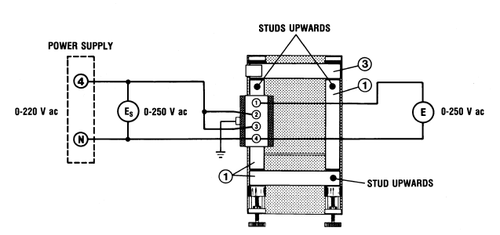

Figure 11. AC Circuit used to determine the polarity of a transformer.

1. Turn on the power and adjust Es to 100 V ac. Measure the value of the series voltage E.

E = _______ V ac

Q3a) Do terminals 2 and 3 have the same or opposite instantaneous polarities?

Same Opposite

Q3b) When terminal 3 is positive with respect to 4, then terminal 1 is ______ with respect to terminal 2. When terminal 2 is negative with respect to terminal 1, then terminal 4 is ________ with respect to terminal 3.

Turn off the power.

1. Set up the circuit as shown in Figure 12. The secondary winding is short-circuited through ammeter I2. Tighten the screws in order to minimize the air gaps in the magnetic circuit.

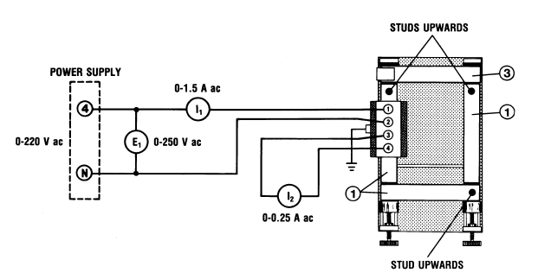

**Figure 12. Circuit used to measure the current ratio and the impedance referred to the primary winding.**

1. Turn on the power and adjust current I1 to 0.8 A ac.

Q4a) Measure E1 and I2.

E1= __________ V ac

I2= ___________ A ac

Turn off the power.

Q4b) Calculate the current ratio I1/I2.

I1/I2=_________

The primary winding (terminals 1 and 2) has 600 turns.

The secondary winding (terminals 3 and 4) has 2400 turns.

Q4c) Calculate the turns ratio.

N2/N1=_________

Q4d) Comment on the proximity of the current ratio found in Q4b and turns ratio found in Q4c.

Q4e) Calculate the impedance of the transformer referred to the primary side.

Z1= E1/I1 = ________ Ω

Knowing that the nominal voltage E1' of the primary winding is 55 V ac and that the nominal current I1' of that winding is 1 A ac, calculate the nominal impedance Zp of the load referred to the primary side. (Each winding has a rating of 55 VA).

Zp= E1'/ I1'=____________Ω

1. Connect one transformer from the three-phase transformer bank (EMS 8348) for open-circuit as illustrated in Figure 13. Note that each transformer is rated at 380/380-220-160 V Use the 4-5 line voltage from the three-phase power supply (EMS8821) to supply an **input voltage of approximately 220V (Line voltage)**. Record the input voltage, current and real power. Then turn the voltage control knob fully CCW (0 position) and turn off the main power supply.

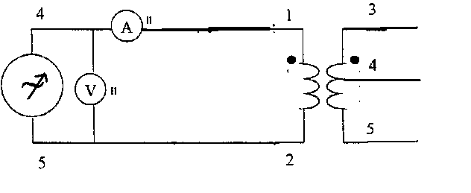

Figure 13. Circuit used to perform open circuit test of a transformer.

|  |  |  |
| --- | --- | --- |
| Quantity | **Value** | **Units** |
| V |  |  |
| I |  |  |
| P |  |  |

Table 3

1. Connect the same transformer used in step 9 for the short circuit as shown in Figure 14. Turn on the power supply. Gradually increase the input voltage with the help of Voltage control knob until the current reaches 0.60 A on the secondary side (**meter I2**) (**you must connect Ammeter in series with the short circuit at the secondary side**). Record the voltage, current and real power. Then turn the voltage control knob fully CCW (0 position) and turn off the main power supply.

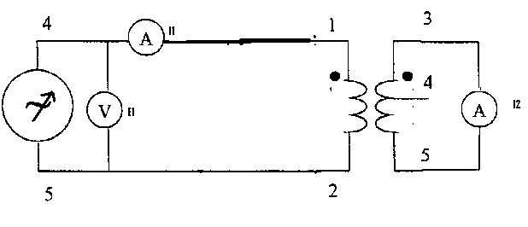

Figure 14. Circuit used to perform short-circuit test of a transformer.

|  |  |  |
| --- | --- | --- |
| **Quantity** | **Value** | **Units** |
| V |  |  |
| I |  |  |
| P |  |  |

Table 4

Q5) From the data obtained in steps 9 and 10, compute and draw the equivalent circuit of the form provided.

1. Connect the same transformer used in step 9 for the short circuit as shown in Figure 14. Turn on the power supply. Gradually increase the input voltage until the current reaches 0.60A. Record the voltage, current and real power. Then turn the Voltage control knob fully CCW (0 position) & turn off the main power supply.

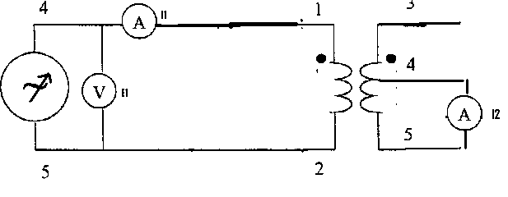

Figure 14.Short Circuit test of a transformer with a different configuration.

|  |  |  |
| --- | --- | --- |
| **Quantity** | **Value** | **Units** |
| V |  |  |
| I |  |  |
| P |  |  |

Table 5

Q6) From the data obtained in steps 9 - 11, compute and draw the equivalent circuit of the form provided.

1. Connect voltmeter to the secondary side of the same transformer used in step 9 and adjust the input voltage at primary side to 220 V (phase voltage) then measure the no load voltage.

Vnl= _________ V

1. Connect resistive load load (R = 685.7 Ω) to the secondary side of the transformer in step 12 and two Watt/Var meter one to the primary side and another one to the secondary side. Then record your measurements of Vfl, Pin and Pout in the following table.

|  |  |  |  |  |
| --- | --- | --- | --- | --- |
| Vfl | Pin | Pout | VR | η |
|  |  |  |  |  |

Table 6

1. Repeat step 13 but use inductive load (XL =j 685.7 Ω ) at the secondary side.

|  |  |  |  |  |
| --- | --- | --- | --- | --- |
| Vfl | Pin | Pout | VR | η |
|  |  |  |  |  |

Table 7

1. Repeat step 13 but use capacitive load (XC = - j 685.7 Ω ) at the secondary side.

|  |  |  |  |  |
| --- | --- | --- | --- | --- |
| Vfl | Pin | Pout | VR | η |
|  |  |  |  |  |

Table 8

1. Repeat step 13 again with load equal to 685.7 + j 685.7 Ω

|  |  |  |  |  |
| --- | --- | --- | --- | --- |
| Vfl | Pin | Pout | VR | η |
|  |  |  |  |  |

Table 9

# Department of Electrical Engineering

|  |  |
| --- | --- |
| **Faculty Member:____________________** | **Dated: _________________** |
| **Semester:__________________________** | **Section: ________________** |

**EE 260: Electro Mechanical System**

**Lab7: Auto-Transformer**

|  |  |  |  |  |
| --- | --- | --- | --- | --- |
| **Name** | **Reg. No** | **Report Marks / 10** | **Viva Marks / 5** | **Total/15** |
|  |  |  |  |  |
|  |  |  |  |  |
|  |  |  |  |  |
|  |  |  |  |  |

**Lab7: Auto-Transformer / P4**

**Objectives:**

**Conduct an Experiment:**

* To be able to connect a standard transformer in both step-up and step-down configurations.
* To get familiarized with autotransformer current and voltage relationships with its turn ratio.

**Equipment:**

|  |  |
| --- | --- |
| **Description** | **Model** |
| Transformer bank | EMS 8341 |
| Variable Resistance | EMS 8311 |
| AC Voltmeter | EMS 8426 |
| AC Ammeter | EMS 8425 |
| Power Supply | EMS 8821 |
| Connection Leads | EMS 8941 |

Table 1

**Discussion:**

**Auto-Transformer:**

An autotransformer is a special type of transformer with only one winding which serves as both the primary and secondary winding of the transformer. When an autotransformer us used to step-up the voltage, only part of the single winding acts as the primary, while the complete winding serves as the secondary. However, when the autotransformer is used to step down the voltage, the complete winding serves as the primary winding and only a part of the complete winding serves as the secondary winding of the autotransformer. Figure 1 shows the two transformer connections in step-up and step-down configurations.

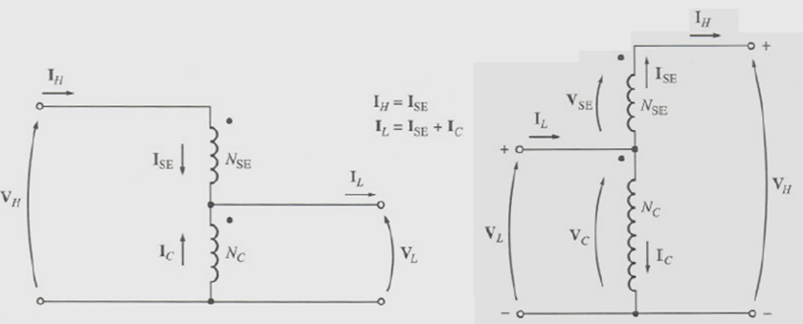

Figure 1. Autotransformer Connections in stepdown configuration (*left*) and stepup configuration (*right*).

Essentially the operation of an autotransformer is same as a standard two-winding transformer except for the electrical connection between the primary and secondary winding in case of an autotransformer. In an autotransformer, power is transferred from the primary to the secondary by both a changing magnetic flux and the electrical connection between the primary and secondary. And like in case of a conventional transformer, the voltage can be stepped up or stepped down depending on the number of turns between the primary and secondary. The relationship between the low voltage, VL, and the high voltage, VH, can be found as follows:



Similarly, the relationship between the currents can be found as follows:



And the relationship between the input and output power of an autotransformer, SIO, and the power in the winding of an autotransformer, SW, can be found as follows:



The real advantage of using an autotransformer lies in its apparent power advantage. The smaller the series winding, the greater is the apparent power advantage. Another advantage of using an autotransformer is that it is more efficient than transformers with separate windings because of its smaller windings.

Autotransformers are mainly used when a small increase or decrease from the primary voltage winding is required in the secondary winding. For example, to boost a power line voltage and compensate for losses caused by long transmission lines, or to reduce the starting voltage of a motor, thus holding down its starting current within reasonable values.

One major disadvantage of an autotransformer is the lack of electrical isolation between the primary and secondary windings since the windings are not separate. Also, it is generally not advisable to use an autotransformer as a large-ratio step-down device because the high voltage primary voltage would be placed across the low voltage load if the low voltage section of the winding became defective and opened up.

**Procedure:**

1. Install the power supply, data acquisition module, resistive load, and single-phase transformer modules in the EMS Workstation.

**CAUTION**

**High voltages are present in this experiment.**

**Do not make any connections with the power ON.**

**Do not make or modify any banana jack connections with the power on unless otherwise specified.**

1. Make sure that the main switch of the power supply is set to the O (OFF) position, and the voltage control knob is turned fully ccw. Set the voltmeter select switch to the 4-N position, and then ensure the power supply is connected to a three-phase wall receptacle.
2. Ensure that the power input of the data acquisition module is connected to the main power supply, and ensure the USB port cable from the computer is connected to the data acquisition module. Set the 24V-AC power switch to the 1 (ON) position.
3. Display the metering application.
4. Set up the autotransformer circuit as shown in Figure 2. Please note that winding 5-6 is connected as the primary, and that center-tap terminal 9 and terminal 6 act as the secondary winding.

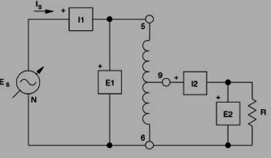

Figure 2. Autotransformer circuit used in step-down configuration.

1. Ensure that all of the resistive load module switched are open. Turn on the main power supply and adjust the voltage control knob till Es is 220 V ac.
2. Set up the resistive load module to obtain the value of R: 440Ω.

Q1)Measure and record the values of:

Voltage across primary winding, EP= __________ V ac

Current in primary winding, IP= ___________ A ac

Apparent power in primary winding, SP= ___________ VA

Voltage across secondary winding, ES= __________ V ac

Current in secondary winding, IS= ___________ A ac

Apparent power in secondary winding, Ss= ___________ VA

1. Compare the values of SP and SS.

Q2) Comment on the proximity of the values of SP and SS.

1. Using the measured values in step 7:

Q3) Calculate the apparent power for both the primary and secondary circuits.

Apparent power in primary winding, SP' = EP x IP = ___________ VA

Apparent power in secondary winding, Ss' = ES x IS =___________ VA

Q4) Comment on the proximity of SP and SP', and ,SS and SS'.

Q5) Quoting results, state whether the autotransformer is connected in step-up or step-down configuration.

Q6) Compute the primary and secondary current ratio. Does it agree with the inverse of the turns ratio?

1. Set up the autotransformer circuit as shown in Figure 3. Note that winding 9-6 is now connected as the primary, and that terminals 5-6 are used for the secondary winding.

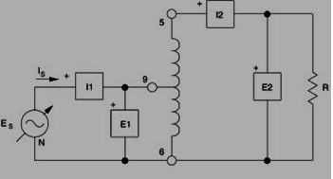

Figure 14. Circuit used to perform short-circuit test of a transformer.

1. Ensure that all of the resistive load module switched are open. Turn on the main power supply and adjust the voltage control knob till Es is 60 V ac.
2. Set the resistive load module to obtain the value of R: 2200 Ω.

Q7)Measure and record the values of:

Voltage across primary winding, EP= __________ V ac

Current in primary winding, IP= ___________ A ac

Apparent power in primary winding, SP= ___________ VA

Voltage across secondary winding, ES= __________ V ac

Current in secondary winding, IS= ___________ A ac

Apparent power in secondary winding, Ss= ___________ VA

1. Compare the values of SP and SS.

Q8) Comment on the proximity of the values of SP and SS.

1. Using the measured values in step 12:

Q3) Calculate the apparent power for both the primary and secondary circuits.

Apparent power in primary winding, SP' = EP x IP = ___________ VA

Apparent power in secondary winding, Ss' = ES x IS =___________ VA

Q4) Comment on the proximity of SP and SP', and ,SS and SS'.

Q5) Quoting results, state whether the autotransformer is connected in step-up or step-down configuration.

Q6) Compute the primary and secondary current ratio. Does it agree with the inverse of the turns ratio?

1. Set up another autotransformer circuit so as to measure the power in each winding SW of the autotransformer.

Q7) Record the values of power in each winding. Are they equal?

Q8) Calculate the ratio of power in the windings SW and input power SP. Does it agree with the turns ratio?

1. Ensure that the power supply is turned off, the voltage control knob is turned fully ccw, and remove all leads and cables.

# Department of Electrical Engineering

|  |  |
| --- | --- |
| **Faculty Member:____________________** | **Dated: ________________** |
| **Semester:__________________________** | **Section: ________________** |

**EE 260: Electro Mechanical System**

**Lab8: Three Phase Transformer Connections & Operation**

|  |  |  |  |  |
| --- | --- | --- | --- | --- |
| **Name** | **Reg. No** | **Report Marks / 10** | **Viva Marks / 5** | **Total/15** |
|  |  |  |  |  |
|  |  |  |  |  |
|  |  |  |  |  |
|  |  |  |  |  |

**Lab8: Three Phase Transformer Connections & Operation / P4**

**Objectives:**

**Conduct an experiment:**

* To learn how to appropriately model three-phase transformers and transformer banks.
* To understand phase relationship in Y-Δ connection.
* To understand and master the connection of three phase transformer banks.

**Equipment:**

|  |  |  |  |
| --- | --- | --- | --- |
| **Sno.** | **Description** | **Module No.** | **Quantity** |
| 1 | Three phase power supply | EMS 8821 | 1 |
| 2 | Phase angle meter | EMS 8451 | 1 |
| 3 | Three phase resistive load | EMS 8311 | 1 |
| 4 | Three phase inductive load | EMS8321 | 1 |
| 5 | Three phase transformer bank | EMS 8348 | 1 |
| 6 | Three phase ammeter | EMS 8425 | 1 |
| 7 | Three phase Watt/VAR meter | EMS8446 | 1 |
| 8 | AC voltmeter | EMS 8426 | 1 |
| 9 | Multimeter | - | 1 |

Table1

**Discussion:**

The primaries and secondaries of any three phase transformer can be connected in either Wye or Delta. This gives us a total of four possible configurations for three phase transformer bank:

1. Wye – Wye (Y-Y):

Vphase = VLine/√3

* The phase of the primary and the secondary voltages are the same.

2. Wye – Delta (Y-∆):

Vp/Vs = √3 * a

While

a: Turns ratio

* Due to Y-∆ connection the secondary voltage is shifted by 30o related to the primary one.

3. Delta – Wye (∆-Y):

Vp/Vs = a/√3

* The secondary voltage lags the primary one by 30o.

4. Delta – Delta (∆-∆):

* This transformer has no phase shift and no problems with the harmonics.

**Procedure:**

For the following steps in this laboratory exercise, connection diagram will be not provided. You will be required to develop them on your own. Also you have to include the detailed connection diagram in your lab reports. Also the term primary will be used to indicate the source side of the transformer bank and the term secondary will be used to indicate the load side of the transformer bank.

1. Connect the three phase transformer bank (EMS8348) Y-Y for 220/220V operation (these values are line-to-line values). Using the three phase resistive load (EMS8311), apply a Y-connected load of 685.7 Ω. Measure and record the magnitude and phase angles of all the six primary voltages and six secondary voltages using 4-N voltage as a reference.

|  |  |  |
| --- | --- | --- |
| **Quantity** | **Magnitude** | **Phase angle (deg.)** |
| Primary | | |
| V4N |  |  |
| V5N |  |  |
| V6N |  |  |
| V45 |  |  |
| V56 |  |  |
| V64 |  |  |
| Secondary | | |
| Van |  |  |
| Vbn |  |  |
| Vcn |  |  |
| Vab |  |  |
| Vbc |  |  |
| Vca |  |  |

Table 2

Q3a) Construct a complete phasor diagram. Does it turn out as expected?

Measure and record the line current magnitudes (from one phase only) on the primary and secondary.

|  |  |  |
| --- | --- | --- |
| Quantity | Magnitude | Units |
| Primary Line Current |  |  |
| Secondary line current |  |  |

Table 3

Q3b) Do your measurements agree with the results produced by analysis of your equivalent circuit assuming known load impedance and load magnitude (taken from the measurement)?

1. Connect the three phase transformer bank (EMS8348) Δ-Δfor 220/220V operation (these values are line-to-line values). Using the three phase resistive load (EMS8311), apply a Y-connected load of 685.7Ω. Measure and record the magnitude and phase angles of all the six primary voltages and six secondary voltages using 4-N voltage as a reference.

|  |  |  |
| --- | --- | --- |
| **Quantity** | **Magnitude** | **Phase angle (deg.)** |
| Primary | | |
| V4N |  |  |
| V5N |  |  |
| V6N |  |  |
| V45 |  |  |
| V56 |  |  |
| V64 |  |  |
| Secondary | | |
| Van |  |  |
| Vbn |  |  |
| Vcn |  |  |
| Vab |  |  |
| Vbc |  |  |
| Vca |  |  |

Table 4

Q4a) Construct a complete phasor diagram. Does it turn out as expected?

Measure and record the line current magnitudes (from one phase only) on the primary and secondary.

|  |  |  |
| --- | --- | --- |
| Quantity | Magnitude | Units |
| Primary Line Current |  |  |
| Secondary line current |  |  |

Table 5

Q4b) Do your measurements agree with the results produced by analysis of your equivalent circuit assuming known load impedance and load magnitude (taken from the measurement)?

Q4c) Since the load is equivalent to step 1, do your results agree? Explain why or why not.

1. Connect the three phase transformer bank (EMS8348) Y-Δfor 220/220V operation (these values are line-to-line values). Using the three phase resistive load (EMS8311) and three-phase inductive load (EMS8321), apply a Y-connected load of 685.7+j685.7Ω. Measure and record the magnitude and phase angles of all the six primary voltages and six secondary voltages using 4-N voltage as a reference.

|  |  |  |
| --- | --- | --- |
| **Quantity** | **Magnitude** | **Phase angle (deg.)** |
| Primary | | |
| V4N |  |  |
| V5N |  |  |
| V6N |  |  |
| V45 |  |  |
| V56 |  |  |
| V64 |  |  |
| Secondary | | |
| Van |  |  |
| Vbn |  |  |
| Vcn |  |  |
| Vab |  |  |
| Vbc |  |  |
| Vca |  |  |

Table 6

Q5a) Construct a complete phasor diagram. Does it turn out as expected?

Measure and record the line current magnitudes (from one phase only) on the primary and secondary.

|  |  |  |
| --- | --- | --- |
| Quantity | Magnitude | Units |
| Primary Line Current |  |  |
| Secondary Line Current |  |  |

Table 7

Q5b) Do your measurements agree with the results produced by analysis of your equivalent circuit assuming known load impedance and load magnitude (taken from the measurement)?

Q5c) Since the load is equivalent to step 1, do your result agree? Explain why or why not.

# Department of Electrical Engineering

|  |  |
| --- | --- |
| **Faculty Member:____________________** | **Dated: ________________** |
| **Semester:__________________________** | **Section: ________________** |

**EE 260: Electro Mechanical System**

**Lab9: Introduction to Machines**

|  |  |  |  |  |
| --- | --- | --- | --- | --- |
| **Name** | **Reg. No** | **Report Marks / 10** | **Viva Marks / 5** | **Total/15** |
|  |  |  |  |  |
|  |  |  |  |  |
|  |  |  |  |  |
|  |  |  |  |  |

**Lab9: Introduction to Machines / P4**

**Objectives:**

**Conduct an experiment:**

* To get familiarized with different machines (DC, Induction, and Synchronous Machine) and their parts.
* To assemble different machines (DC, Induction, and Synchronous Machine) and appreciate the working and placement of different parts in a machine.

**Equipment:**

**For DC Machine:**

|  |  |  |  |
| --- | --- | --- | --- |
| **Item** | **Quantity** | **Description** | **Part No.** |
| 1 | 1 | Support Module | 8163 |
| 2 | 1 | Faceplate | 8211-D5 |
| 3 | 1 | Pulley | 25834 |
| 4 | 4 | Wing head screw | 25843 |
| 5 | 1 | Brush yoke end-bell | 25832 |
| 6 | 1 | Stator | 22037-D5 |
| 7 | 1 | DC rotor | 22038-D5 |
| 8 | 1 | Rear end-bell | 29088-5 |
| 9 | 1 | Potentiometer 1000Ω | 25836-5 |

**Table 01**

**For Three Phase Wound-Rotor Induction Motor:**

|  |  |  |  |
| --- | --- | --- | --- |
| **Item** | **Quantity** | **Description** | **Part No.** |
| 1 | 1 | Support Module | 8163 |
| 2 | 1 | Faceplate | 8231-D5 |
| 3 | 1 | Pulley | 25834 |
| 4 | 4 | Wing head screw | 25843 |
| 5 | 1 | Front end-bell | 23662-7 |
| 6 | 1 | Stator | 22062-D5 |
| 7 | 1 | Rotor | 22190-D5 |
| 8 | 1 | Rear end-bell | 23662-8 |
| 9 | 1 | Brush holder | 25842 |

**Table 02**

**For Three Phase Squirrel Cage Induction Motor:**

|  |  |  |  |
| --- | --- | --- | --- |
| **Item** | **Quantity** | **Description** | **Part No.** |
| 1 | 1 | Support Module | 8163 |
| 2 | 1 | Faceplate | 8211-D5 |
| 3 | 1 | Pulley | 25834 |
| 4 | 4 | Wing head screw | 25843 |
| 5 | 1 | Front end-bell | 25832 |
| 6 | 1 | Stator | 22037-D5 |
| 7 | 1 | Rotor | 22038-D5 |
| 8 | 1 | Rear end-bell | 29088-5 |

Table 03

**For Synchronous Machine:**

|  |  |  |  |
| --- | --- | --- | --- |
| **Item** | **Quantity** | **Description** | **Part No.** |
| 1 | 1 | Support Module | 8163 |
| 2 | 1 | Faceplate | 8241-D5 |
| 3 | 1 | Pulley | 25834 |
| 4 | 4 | Wing head screw | 25843 |
| 5 | 1 | Front end-bell | 23662-7 |
| 6 | 1 | Stator | 22062-D5 |
| 7 | 1 | Rotor | 22094-D5 |
| 8 | 1 | Rear end-bell | 23662-8 |
| 9 | 1 | Brush Holder | 25842 |
| 10 | 1 | Potentiometer 500Ω | 25835-5 |

Table 04

**Discussion:**

**DC Machines:**

DC machines are generators that convert mechanical energy to dc electrical energy and motors that convert dc electrical energy to mechanical energy. Most dc machines are like ac machines in that they have ac voltages and currents within them - dc machines have a dc output only because a mechanism exists that converts the internal ac voltage to dc voltages at their terminals. Since this mechanism is also called a commutator, dc machinery is also known as *commutating machinery*.

**Induction Motor:**

An induction motor or asynchronous motor is the most commonly used industrial motor, finding application in many situations where speed regulation is not essential. It is simple and relatively inexpensive. There are two general types of Induction Motors: the squirrel-cage type and the wound rotor machine. Both motors have an armature or stator structure similar to that of the alternating current generator, consisting of a hollow cylinder of laminated sheet steel in which are punched longitudinal slots.

These motors are widely used in industrial drives because they are robust and have no brushes.

**Synchronous Machine:**

Synchronous machines is an important electromechanical energy converter. Synchronous generators usually operate together (or in parallel) forming a large power system supplying electrical energy to the loads or consumers. For these applications synchronous machines are built in large units, their rating ranging from tens to hundreds of megawatts. For high-speed machines, the prime movers are usually steam turbines employing fossil or nuclear energy resources. Low speed machines are often driven by hydro-turbines that employ water power for generation. Smaller synchronous machines are sometimes used for private generation and as standby units, with diesel engines or gas turbines as prime movers.

Synchronous machines can also be used as motors, but they are usually built in very large sizes. The synchronous motor operates at a precise synchronous speed, and hence is a constant-speed motor. Unlike the induction motor, whose operation always involves a lagging power factor, the synchronous motor possesses a variable power-factor characteristic, and hence is suitable for power factor correction applications.

**DC MACHINE - ASSEMBLY**

Recommendations:

Be sure to use *only* the parts called for in the exercise. Many parts look similar but have different electrical characteristics.

Keep your work table clear. Have only the parts needed for each assembly step.

No tools are required to assemble the machine. However, a mallet is included to mount the end-bells to the frame.

Refer to the exploded view drawing (Figure 01) before performing each assembly step.

**Procedure:**

1. Assembling the rotor (Item 7) to the front end-bell (Item 5).
2. Hold the rotor (7) in a vertical position with the commutator end at the top.
3. Slide the end-bell (5) over the rotor shaft. With the tip of your index fingers, push back both brushes simultaneously. Apply hand pressure to the end bell to push the bearing into the end-bell housing. Release the brushes.
4. Be careful not to damage the brushes or the commutator. If necessary use the mallet to seat the bearing in the housing.
5. Coupling the end-bells to the stator frame (Items 4,6, and 8).
6. Place the stator (Item 6) on the work table with the connector plug at the rear as in Figure 1. Insert the assembled rotor/end-bell inside the stator with the brush-shifting lever in the upward position. Be careful not to scratch the wires of the stator winding.
7. Align the end-bell assembly holes with the holes in the stator.
8. Insert the four wing head screws (Item 4) into the front end-bell and through the stator assembly hole.
9. Mount the front end-bell to the frame. Use the mallet, if necessary.
10. Slide the rear end-bell (Item 8) over the rotor shaft. Feed the connector plug out through the bottom opening of the end-bell. The larger opening must be at the top.
11. Align the rear end-bell assembly holes with the stator holes and mount the end-bell to the frame. Use the mallet, if necessary.
12. Engage the assembly screws in the rear end-bell. Secure the end-bells to the frame by tightening each screw alternately. Hand-tighten evenly.
13. Rotate the shaft by hand in both directions to ensure that the rotor is centered inside the stator and turns freely.
14. Installing the pulley (Item 3) on the shaft of the machine.
15. Slide the pulley (Item 3) over the front end of the shaft. Line up the pulley keyway with the shaft key. Push firmly to lock the pulley in place against the stopper ring.
16. Setting the machine on the support module (Item 1).
17. Place the assembled machine on the base of the support module (1) between hold-down clamps X and Y (pulley side toward the front of the module). Make sure that the clamps are turned as shown in Figure 1. Line up the two holes in the stator base with the studs between the two clamps and seat the machine on the support base.
18. Turn the hold-down clamps 90o so that the plastic pins engage in the slots on the stator base. Hand-tighten the wing nuts to fasten the machine to the support base.
19. Electrical connections and mounting of the components on the support module.
20. Plug the polarized male connector A from the stator into the corresponding female connector A on the support base.
21. Plug the polarized male connector B from the brush yoke end-bell into the corresponding female connector B on the support base.
22. Install the schematic symbols faceplate (Item 2) in the front panel of the support module and hand tighten the retaining screws.
23. Unscrew the front panel retaining screws and lower the hinged panel.
24. Install the variable-resistance/breaker unit (Item 9) from the rear and hand-tighten the retaining screws.
25. Raise the front panel and secure it with the retaining screws.
26. Congratulations! You have just assembled a direct current machine.

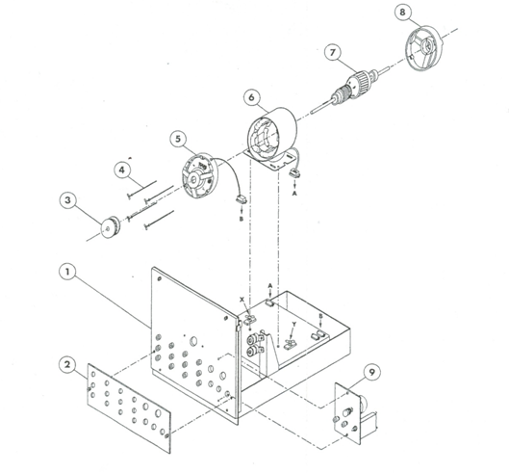

Figure 01. Exploded view of a DC Machine.

**THREE PHASE WOUND-ROTOR INDUCTION MOTOR - ASSEMBLY**

Recommendations:

Be sure to use *only* the parts called for in the exercise. Many parts look similar but have different electrical characteristics.

Keep your work table clear. Have only the parts needed for each assembly step.

No tools are required to assemble the machine. However, a mallet is included to mount the end-bells to the frame.

Refer to the exploded view drawing (Figure 02) before performing each assembly step.

**Procedure:**

1. Assembling the rotor (Item 7) to the front end-bell (Item 5).
2. Hold the rotor (Item 7) in a vertical position with the slip ring end at the bottom.
3. Slide the end-bell (Item 5) over the rotor shaft. Apply hand pressure to the end-bell to push the bearing into the end-bell housing. If necessary, use the mallet to seat the bearing on the housing.
4. Coupling the end-bells to the stator (Item 6) frame.
5. Place the stator (Item 6) on the work table with the connector plug at the rear as shown in Figure 02. Insert the assembled rotor/end-bell inside the stator. Be careful not to scratch the wires of the stator winding or the finished surface of the rotor.
6. Align the end-bell assembly holes with the holes in the stator.
7. Insert the four wing head screws (4) into the front end-bell and through the stator assembly holes.
8. Mount the front end-bell to the frame. Use the mallet if necessary.
9. Slide the rear end-bell (Item 8) over the slip rings on the rotor shaft. (Be careful not to scratch the polished surface of the slip rings.) Feed the connector plug out through the bottom opening of the end-bell. The larger opening must be at the top.
10. Align the rear end-bell assembly holes with the stator holes and mount the end-bell to the frame. Use the mallet, if necessary.
11. Engage the assembly screws in the rear end-bell. Secure the end-bells to the frame by tightening each screw alternately. Hand-tighten evenly.
12. Rotate the shaft by hand in both directions to ensure that the rotor is centered inside the stator an runs freely.
13. Installing the pulley (Item 3) on the motor shaft.
14. Slide the pulley (Item 3) over the front end of the shaft. Line up the pulley keyway with the shaft key. Push firmly to lock the pulley in space against the stopper ring.
15. Installing the brush holder (Item 9) on the rear end-bell.
16. Slide the brush holder (Item 9) over the rear end of the shaft by successively clearing and releasing the brushes over the slip rings. (Be careful not to scratch the brushes or the polished surface of the slip rings.) Secure the brush holder to the rear end-bell by tightening the retaining screws.
17. Setting the motor on the support module (Item 1).
18. Place the assembled motor on the base of the support module (Item 1) between hold down clamps X and Y (pulley side toward the front of the module.) Make sure that the clamps are turned are shown in Figure 02. Line up the two holes in the stator base with the studs between the two clamps and seat the motor on the support base.
19. Turn the hold down clamps 90o so that the plastic pins engage in the slots on the stator base. Hand-tighten the wing nuts to fasten the motor to the support base.

1. Electrical connections and mounting of the faceplate (Item 2) on the support module.
2. Plug the polarized male connector A from the stator into the corresponding female connector A on the support base.
3. Plug the polarized male connector B from the brush holder (Item 11) into the corresponding female connector B on the support base.
4. Install the schematic symbols faceplate (Item 2) on the front panel of the support module and hand tighten the retaining screws.
5. Congratulations! You have just assembled a three phase wound-rotor induction motor.

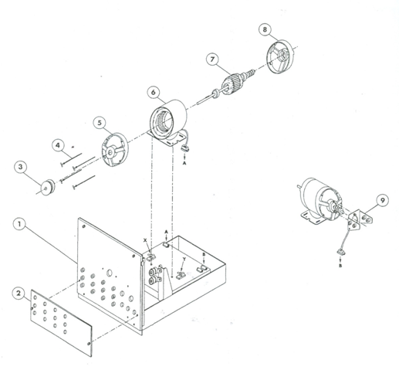

Figure 02. Exploded view of a three phase wound-rotor Induction Motor.

**THREE PHASE SQUIRREL CAGE INDUCTION MOTOR - ASSEMBLY**

Recommendations:

Be sure to use *only* the parts called for in the exercise. Many parts look similar but have different electrical characteristics.

Keep your work table clear. Have only the parts needed for each assembly step.

No tools are required to assemble the machine. However, a mallet is included to mount the end-bells to the frame.

Refer to the exploded view drawing (Figure 03) before performing each assembly step.

**Procedure:**

1. Assembling the rotor (Item 7) to the front end-bell (Item 5).
2. Hold the rotor (Item 7) in a vertical position with the key end of shaft at the top.
3. Slide the end-bell (Item 5) over the rotor shaft. Apply hand-pressure to the end-bell to push the bearing into the end-bell housing. If necessary, use the mallet to seat the bearing in the housing.
4. Coupling the end bells to the stator (Item 6) frame.
5. Place the stator (Item 6) on the work table with the connector plug at the rear as shown in Figure 03. Insert the assembled rotor /end-bell inside the stator. Be careful not to scratch the finished surface of the rotor.
6. Align the end-bell assembly holes with the holes in the stator.
7. Insert the four wing head screws (Item 4) into the front end-bell and through the stator assembly holes.
8. Mount the front end-bell to the frame. Use the mallet, if necessary.
9. Slide the rear end-bell (item 8) over the rotor shaft. Feed the connector plug out through the bottom opening of the end-bell. The larger opening must be at the top.
10. Align the rear end-bell assembly holes with the stator holes and mount the end-bell to the frame. Use a mallet, if necessary.
11. Engage the assembly screws in the rear end-bell. Secure the end-bells to the frame by tightening each screw alternately. Hand-tighten evenly.
12. Rotate the shaft by hand in both directions to ensure that the rotor is centered inside the stator and turns freely.
13. Installing the pulley on the motor shaft.
14. Slide the pulley (Item 3) over the front end of the shaft. Line up the pulley keyway with the shaft key. Push firmly to lock the pulley in place against the stopper ring.
15. Setting the motor on the support module (Item 1).
16. Place the assembled motor on the base of the support module (Item 1) between the hold-down clamps X and Y (pulley side toward the front of the module). Make sure that the clamps are turned as shown in Figure 03. Line up the two holes in the stator base with the studs between the two clamps and seat the motor on the support base.
17. Turn the hold-down clamps 90o so that the plastic pins engage in the slots on the stator base. Hand-tighten the wing nuts to fasten the motor to the support base.
18. Electrical connections and mounting of the faceplate (item 2) on the support module.
19. Plug the polarized male connector A from the stator into the corresponding female connector A on the support base.
20. Install the schematic symbols faceplate (Item 2) on the front panel of the support module and hand-tighten the retaining screws.
21. Congratulations! You have just assembled a three phase squirrel cage induction motor.

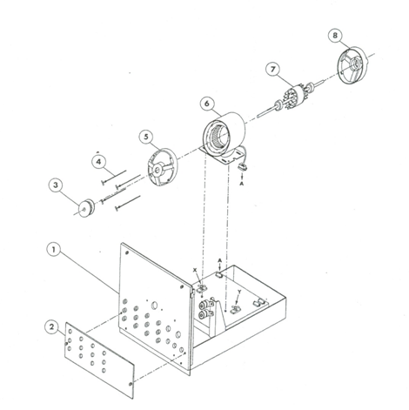

Figure 03. Exploded view of a three phase squirrel cage Induction Motor.

**SYNCHRONOUS MACHINE - ASSEMBLY**

Recommendations:

Be sure to use *only* the parts called for in the exercise. Many parts look similar but have different electrical characteristics.

Keep your work table clear. Have only the parts needed for each assembly step.

No tools are required to assemble the machine. However, a mallet is included to mount the end-bells to the frame.

Refer to the exploded view drawing (Figure 04) before performing each assembly step.

**Procedure:**

1. Assembling the rotor (Item 7) to the front end-bell (Item 5).
2. Hold the rotor (Item 7) in a vertical position with the slip ring end at the bottom.
3. Slide the end-bell (Item 5) over the rotor shaft. Apply hand pressure to the end-bell to push the bearing into the end-bell housing. If necessary, use the mallet to seat the bearing in the housing.
4. Coupling the end-bells to the stator (Item 6) frame.
5. Place the stator (Item 6) on the work table with the connector plug at the rear as shown in Figure 04. Insert the assembled rotor/end-bell inside the stator. Be careful not to scratch the wires of the stator winding or the finished surface of the rotor.
6. Align the end-bell assembly holes with the holes in the stator.
7. Insert the four wing head screws (Item 4) into the front end-bell and through the stator assembly holes.
8. Mount the front end-bell to the frame. Use the mallet, if necessary.
9. Slide the rear end-bell (Item 8) over the slip rings on the rotor shaft. (Be careful not to scratch the polished surface of the slip rings.) Feed the connector plug out through the bottom opening of the end-bell. The larger opening must be at the top.
10. Align the rear end-bell assembly holes with the stator holes and mount the end-bell to the frame. Use the mallet, if necessary.
11. Engage the assembly screws in the rear end-bell. Secure the end-bells to the frame by tightening each screw immediately. Hand-tighten evenly.
12. Rotate the shaft by hand in both directions to ensure that the rotor is centered inside the stator and turns freely.
13. Installing the pulley (Item 3) on the shaft of the machine.
14. Slide the pulley (Item 3) over the front end of the shaft. Line up the pulley keyway with the shaft key. Push firmly to lock the pulley in place against the stopper ring.
15. Installing the brush holder (Item 9) on the rear end-bell.
16. Slide the brush holder (Item 9) over the rear end of the shaft by successively clearing and releasing the brushes over the slip rings. (Be careful not to scratch the brushes of the polished surface of the slip rings.) Secure the brush holder to the rear end-bell by tightening the retaining screws.

1. Setting the machine on the support module (Item 1).
2. Place the assembled machine on the base of the support module (Item 1) between the hold down clamps X and Y (pulley side toward the front of the module. ) Make sure that the clamps are turned as shown in Figure 04. Line up the two holes in the stator base with the studs between the two clamps and seat the machine on the support base.
3. Turn the hold down clamps 90o so that the plastic pins engage in the slots on the stator base. Hand-tighten the wing nuts to fasten the machine to the support base.
4. Electrical connections and mounting of the components on the support module.
5. Plug the polarized male connector A from the stator into the corresponding female connector A on the support base.
6. Plug the polarized male connector B from the brush holder into the corresponding female connector B on the support base.
7. Install the schematic symbols faceplate (Item 2) on the front panel of the support module and hand-tighten the retaining screws.
8. Unscrew the front panel retaining screws and lower the hinged panel.
9. Install the variable-resistance/breaker unit (Item 10) from the rear and hand-tighten the retaining screws. Plug lead C into female banana jack C located on the front panel.

f) Raise the front panel and secure it with the retaining screws.

1. Congratulations! You have just assembled a synchronous machine.

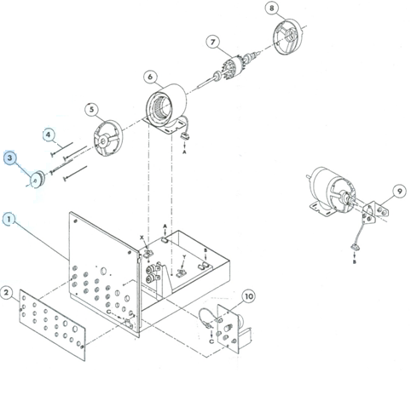

Figure 04. Exploded view of a Synchronous Machine.

# Department of Electrical Engineering

|  |  |
| --- | --- |
| **Faculty Member:____________________** | **Dated: ________________** |
| **Semester:__________________________** | **Section: ________________** |

**EE 260: Electro Mechanical System**

**Lab10: Three Phase Alternator Characteristics**

|  |  |  |  |  |
| --- | --- | --- | --- | --- |
| **Name** | **Reg. No** | **Report Marks / 10** | **Viva Marks / 5** | **Total/15** |
|  |  |  |  |  |
|  |  |  |  |  |
|  |  |  |  |  |
|  |  |  |  |  |

**Lab10: Three Phase Alternator Characteristics / P4**

**Objectives:**

**Conduct an experiment:**

* To obtain no load saturation curve of the alternator.
* To obtain the short- circuit characteristics of the alternator.
* To determine the voltage regulation characteristics of the alternator with resistive, capacitive and inductive loading.
* To observe the effect of unbalanced loads on the output voltage.

**Equipment:**

|  |  |  |  |
| --- | --- | --- | --- |
| **S No.** | **Description** | **Module No.** | **Quantity** |
| 1 | Three phase power supply | EMS 8821 | 1 |
| 2 | Synchronous Motor/Generator | EMS 8241 | 1 |
| 3 | Four – pole Squirrel Cage Induction Motor | EMS 8221 | 1 |
| 4 | Synchronizing Module | EMS 8621 | 1 |
| 5 | DC Voltmeter/ Ammeter | EMS 8412 | 1 |
| 6 | Voltmeter | EMS 8426 | 1 |
| 7 | Ammeter | EMS 8425 | 1 |
| 8 | Timing Belt | EMS 8942 | 1 |
| 9 | Connecting Leads Set | EMS 8941 | 1 |
| 10 | Variable Resistance | EMS 8311 | 1 |
| 11 | Variable Inductance | EMS 8321 | 1 |
| 12 | Variable Capacitance | EMS 8331 | 1 |
| 13 | Hand Tachometer | EMS 8920 | 1 |

Table 1

**Discussion:**

Alternators are the most important source of electric energy. Alternators generate an Ac voltage whose frequency depends entirely on the speed of rotation.

fe = nm P/120

Where:

fe = electrical frequency.

nm = speed of rotor.

P = number of poles.

The output voltage of an alternator (ac generator) depends on the speed, power factor of the load and essentially on the total flux in the air-gap.

EA = Kф w

Where:

K = constant.

ф = flux in the machine

w = electrical radians per second

As the Dc field excitation of the alternator is increased, while its speed is held constant, the magnetic flux and the output voltage will increase in direct proportion to the current. However, with progressive increases in the Dc field current, the flux will eventually reach a high enough value to saturate the iron in the alternator. Which means that there will be smaller increase in the flux for given increase in Dc field current. Because the generated voltage directly related to the magnetic flux intensity, it can be used as a measure of the degree of saturation.

The equivalent circuit for a synchronous generator contains three quantities that must be determined:

1. The relation between field current and flux.
2. The synchronous reactance.
3. The armature resistance.

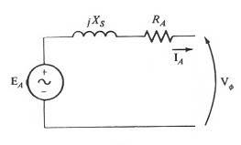

Figure 1- Equivalent circuit of a synchronous generator.

The following technique used to determine these quantities:

1. **Open circuit test:**

The generator turned at rated speed, the terminals are disconnected from all loads and the field current gradually increased from zero then reassured the terminal voltage at each step. In this case EA = VT due to open load ( IA = zero)

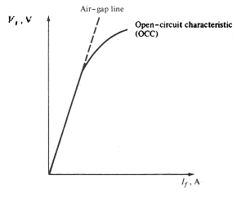

Figure 2- Open circuit characteristics.

1. **Short circuit test:**

In this test the terminals of the generator shorted by using ammeters to measure the armature current while the field current increases from zero.

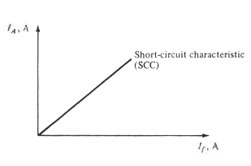

Figure 3- Short circuit test.

The internal machine impedance equal:

Zs = √ (RA2 + Xs2) = EA/IA

So from the open and short circuit test we can determine EA and IA at same field current. But it should be in the linear region to accurate.

At no load, this flux is established and determined exclusively by the dc field excitation. Under load, however, the air-gap flux is determined by the ampere-turns of the rotor and the ampere-turns of the stator. The latter may aid or oppose the MMF (magneto­motive force) of the rotor depending on the power factor of the load. Leading power factors assist the rotor, and lagging power factors oppose it.

Because the stator MMF has such an important effect on the magnetic flux, the vol­tage regulation of alternators is quite poor. That is why the dc field current must con­tinuously be adjusted to keep the voltage constant under variable load conditions.

If one phase of a three-phase alternator is heavily loaded, its voltage will decrease due to the IA and XL drops in the stator winding. This voltage drop cannot be com­pensated for by modifying the dc field current because the voltages of the other two phases will also be changed. Therefore, it is essential that three-phase alternators do not have loads that are badly unbalanced.

**Procedure:**

**Warning: high voltages are present in this laboratory experiment! Do not make any connections with the power on! The power should be turned off after completing each individual!**

**No load characteristics:**

1. Using your Synchronous Motor/Generator, four pole Squirrel Cage induction motor, power supply, DC Voltmeter/Ammeter, AC Ammeter and AC Voltmeter, connect the circuit shown in Figure 4. The four pole Squirrel Cage induction motor will be used to drive the Synchronous Motor/Generator as an alternator. Its speesserd will be assumed constant during this laboratory experiment. Note that the four pole Squirrel Cage induction motor is connected to fixed 380 V Ac, 3-phase output of the power supply terminals 1,2 and 3. The rotor of the alternator is connected to the variable 0-220 V Dc output of the power supply, terminals 7 and N.

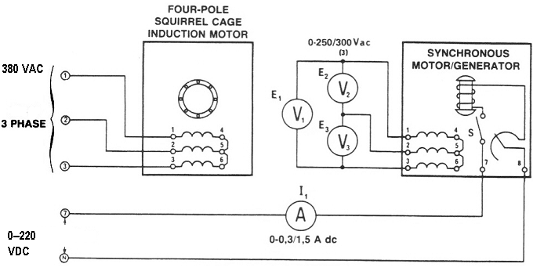

Figure 4

2. a) Couple the four pole Squirrel Cage induction motor to the Synchronous Motor/Generator with the timing belt.

b) Set the field rheostat of the Synchronous Motor/Generator at its full cw position( for zero resistance).

c) Set the power supply voltage control at its full ccw position( for zero Dc voltage)

3. a) Turn on the power supply. The motor should be running.

b) With zero Dc excitation (switch S open), measure and record E1 and E3 (use the lowest ranges of the voltmeters)

E1 = ………….V Ac E 2=..................V Ac E3 = ………….V Ac

c) Explain why there is an Ac voltage generated in the absence of Dc excitation.

4. a) Turn on the rotor excitation toggle switch of the Synchronous Motor/Generator(down position). Gradually increase the Dc excitation from zero to 0.05 A Dc using the power supply voltage control.

b) Measure and record in table 2 the three generated voltages E1, E2 and E3

|  |  |  |  |  |
| --- | --- | --- | --- | --- |
| **I1**  **A** | **E1**  **V** | **E2**  **V** | **E3**  **V** | **Eave** |
| **0** |  |  |  |  |
| **0.05** |  |  |  |  |
| **0.1** |  |  |  |  |
| **0.15** |  |  |  |  |
| **0.2** |  |  |  |  |
| **0.25** |  |  |  |  |
| **0.3** |  |  |  |  |
| **0.35** |  |  |  |  |

Table 2

c) Repeat b) for each of the Dc current listed in table 2.

d) Return the voltage to zero and turn of the power supply

5. a) Calculate and record in table 2 the average output voltage of the Synchronous Motor/Generator for each of listed Dc currents.

b) Plot your recorded average voltage values (y-axis) vs Dc current (x-axis) values from table 2.

**Short circuit characteristics:**

6. Use your synchronizing module to connect the circuit shown in figure 5. Note that the switch is wired to present a dead short across the alternator windings when it is closed.

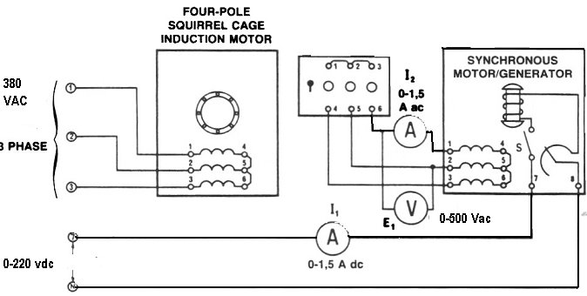

Figure 5

7. a) Couple the four pole Squirrel Cage induction motor to the Synchronous Motor/Generator with the timing belt.

b) Set the field rheostat of the Synchronous Motor/Generator at its full ccw position( for max. resistance).

c) Set the power supply voltage control at its full ccw position( for zero Dc voltage).

8. a) Turn on the power supply. The motor should be running.

b) Close the rotor excitation switch of the Synchronous Motor/Generator.

c) Apply short circuit to your alternator by closing the synchronizing switch.

1. a) Gradually increase the Dc excitation from zero to 0.2 A Dc using the power supply voltage control.

b) Measure and record I2 in table 3.

|  |  |
| --- | --- |
| **I1**  **A (Dc)** | **I2**  **A (Ac)** |
| **0** |  |
| **0.05** |  |
| **0.1** |  |
| **0.15** |  |
| **0.2** |  |

Table 3

c) Plot the field Dc current I1 (x-axis) vs the armature current I2 (y-axis).

**Load test characteristics:**

1. Connect the equipment as shown in figure 6.

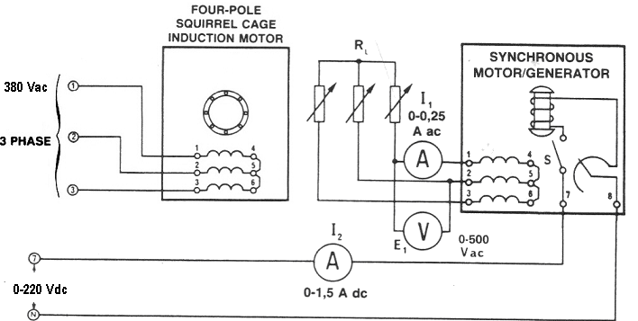

Figure 6

11. a) Couple the four pole Squirrel Cage induction motor to the Synchronous Motor/Generator with the timing belt.

b) Set the field rheostat of the Synchronous Motor/Generator at its full cw position( for zero resistance).

c) Set the power supply voltage control at its full ccw position( for zero Dc voltage).

d) Connect the three phase resistive load to the synchronous generator output.

e) Turn on the power supply. The motor should be running.

f) Adjust the dc excitation of the alternator until the output voltage E1 = 380 V Ac at no load case.

1. Adjust the resistive load to the values shown in table 4 then measure and record the terminal voltage VT and the armature current I1.

|  |  |  |  |
| --- | --- | --- | --- |
| **R**  **Ω** | **VT**  **V (Ac)** | **I1**  **A (Ac)** | **VR** |
| **∞** | **380** |  |  |
| **1100** |  |  |  |
| **2200** |  |  |  |
| **4400** |  |  |  |
| **733** |  |  |  |
| **1467** |  |  |  |
| **629** |  |  |  |

Table 4

1. Return the voltage to zero and turn off the power supply.
2. Calculate and record in table 4 the alternator voltage regulation.

VR = (Vnl – Vfl/**/** Vfl ) x 100 %

1. Plot the load characteristics (VT (y-axis) vs I1 (x-axis)).
2. Repeat step 11 for three phase inductive load.

|  |  |  |  |
| --- | --- | --- | --- |
| **XL**  **Ω** | **VT**  **V (Ac)** | **I1**  **A (Ac)** | **VR** |
| **∞** | **380** |  |  |
| **1100** |  |  |  |
| **2200** |  |  |  |
| **4400** |  |  |  |
| **733** |  |  |  |
| **1467** |  |  |  |
| **629** |  |  |  |

Table 5

1. Repeat steps 13, 14 and 15.
2. With an inductive load, does the stator MMF aid or oppose the rotor MMF?

Aid Oppose

1. Repeat step 11 for three phase capacitive load but adjust the Dc excitation of the alternator until the output voltage **E1 = 255 V Ac** at no load case.

|  |  |  |  |
| --- | --- | --- | --- |
| **XC**  **Ω** | **VT**  **V (Ac)** | **I1**  **A (Ac)** | **VR** |
| **∞** | **255** |  |  |
| **1100** |  |  |  |
| **2200** |  |  |  |
| **4400** |  |  |  |
| **733** |  |  |  |
| **1467** |  |  |  |
| **629** |  |  |  |

Table 6

1. Repeat steps 13, 14 and 15.
2. With capacitive load, does the stator MMF aid or oppose the rotor MMF?

Aid Oppose

**Unbalanced load:**

Connect the circuit shown in. Figure 7.***Note that only one of the alternator phases has a load.***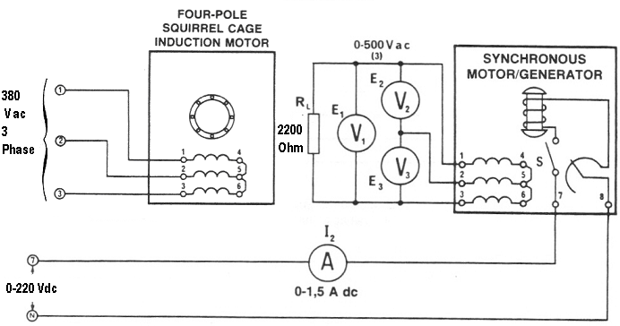

Figure 7

1. Adjust the dc excitation of the alternator until the voltage E, across the 2200 Ω load is 380 V ac. Measure and record the two other phase vol­tages E2 and E3.

E2 = …………… V Ac

E3 = …………… V Ac

1. ***Turn off the Power Supply without touching any of the variable controls.***
2. ***Reconnect the three AC voltmeters so they will measure the voltages across each of the three stator windings.***
3. Turn on the Power Supply. Measure and record the voltages across each of the alternator windings.

E 1 to 4 = ……………………… V ac

E 2 to 5 = ……………………… V ac

E 3 to 6 = ……………………… V ac

1. Return the voltage to zero and turn off the Power Supply.
2. Did the single-phase load produce a large unbalance?

Yes No

**Analysis:**

1. Explain why the alternator output voltage increases with capacitance loading.
2. Could it be dangerous to connect an alternator to a long transmission line, if the line had a high capacitance? Explain.

Yes No

1. The rotor of an alternator, at rated power, dissipates more heat at a low power factor (lagging) load than at a high power factor load, explain.

**Note:**

1. Produce your analysis based on the objectives and the results obtained.

Submit a Formal and group Laboratory Report

# 

# Department of Electrical Engineering

|  |  |
| --- | --- |
| **Faculty Member:____________________** | **Dated: ________________** |
| **Semester:__________________________** | **Section: ________________** |

**EE 260: Electro Mechanical System**

**Lab11: Alternator Synchronization**

|  |  |  |  |  |
| --- | --- | --- | --- | --- |
| **Name** | **Reg. No** | **Report Marks / 10** | **Viva Marks / 5** | **Total/15** |
|  |  |  |  |  |
|  |  |  |  |  |
|  |  |  |  |  |
|  |  |  |  |  |

**Lab11: Alternator Synchronization / P4**

**OBJECTIVES:**

**Conduct an experiment:**

* To learn how to synchronize an alternator to the electric power utility system.
* To observe the effects of improper phase conditions on the synchronizing proc­ess.

**EQUIPMENT:**

|  |  |  |
| --- | --- | --- |
| **Description** | **Module No.** | **Quantity** |
| Three phase power supply | 8821 | 1 |
| Synchronous Motor/Generator | 8241 | 1 |
| DC/Motor Generator | 8211 | 1 |
| Synchronizing Module | 8621 | 1 |
| Voltmeter | 8426 | 1 |
| Ammeter | 8425 | 1 |
| Hand Tachometer | 8920 | 1 |
| Timing Belt | 8942 | 1 |
| Connecting Leads Set | 8941 | 1 |

Table 1

**DISCUSSION:**

The frequency of a large electric power distribution system is established by the speed of rotation of many powerful alternators all connected by various tie-lines in the total network. The collective inertia and power of these generators is so great that there is no single load or disturbance which would be large enough to change their speed of rotation. The frequency of an electric system is, therefore, remarkably stable.

An alternator can only deliver power to an existing electric power system if it oper­ates at the same frequency as the system. A system whose frequency is 50 Hz cannot receive power from an alternator operating at 50.01 Hz. They must both operate at exactly the same frequency. This is not as difficult to achieve as may appear at first, because (when an alternator is connected into an existing system) automatic forces come into play to keep its frequency constant.

Synchronization of an alternator with a large utility system, or “infinite bus’ as it is called is comparable to matching a small gear to another of enormous size and power. If the teeth of both gears are properly synchronized upon contact, then the matching will be smooth. But should the teeth edges meet shock would result with possible damage to the smaller gear.

Smooth synchronization of an alternator means first that its frequency must be equal to that of the supply. In addition, the phase sequence (or rotation) must be the same. Returning to our example of the gears, we would not think of trying to mesh two gears going in opposite directions, even if their speeds were identical.

The next thing to watch for when we push gears together is to see that the teeth of one meet the slots of the other. In electrical terms the voltage of the alternator must be in phase with the voltage of the supply.

Finally, when matching gears we always choose a tooth depth which is compatible with the master gear. Electrically, the voltage amplitude of the alternator should be equal to the supply voltage amplitude. With these conditions met, the alternator is perfectly synchronized with the network and the switch between the two can be turned on.

**PROCEDURE:**

**Warning: *High voltages are present in this Laboratory Experiment! You must ask the instructor to check your connections before turn the power on! The power should be turned off after completing each individual measurement!***

* Using your Synchronous Motor/Generator, DC Motor/Generator, Synchronizing Module, Power Supply, AC Ammeter and AC Voltmeter, connect the circuit shown in Figure 1. Note that the output of the alternator is connected through the Synchronizing Module to the fixed 415 V, 3-phase output of the Power Supply, terminals 1, 2 and 3. The rotor of the alternator is connected to the fixed 240 V dc output of the Power Sup­ply, terminals 8 and N. The dc shunt motor is connected to the variable 0-240 V dc output of the Power Supply, terminals 7 and N.
* Couple the DC Motor/Generator to the alternator (Synchronous Motor/ Generator) with the Timing Belt.
* Set the field rheostat of the DC Motor/Generator at its full cw position (for minimum resistance).

**Warning: Do not forget this part**

* + - * + Place the synchronizing switch in its open position.

1. Turn on the Power Supply. Using your Hand Tachometer, adjust the rheostat of the DC Motor/Generator for a motor speed of 1500 r/ min.

1. Measure the Power Supply fixed ac voltage E2.

E2 = ……………………… V ac

1. Close the toggle switch of the alternator excitation circuit and adjust the dc excitation of the alternator until the alternator output voltage E1 is equal to E2.

**Note:** ***These two voltages must be kept equal for the remainder of this Laboratory Experiment.***

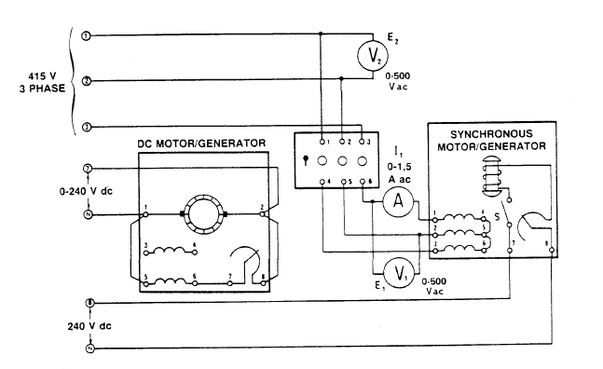

Figure 1

* The three synchronizing lights should be flickering on and off.
* Carefully adjust the DC Motor/Generator speed until the beat fre­quency becomes quite low.

* Do all three lights become bright and then dark, at the same time?

Yes No

* If they do not all become dark and then bright simultaneously, the phase sequence is wrong.
* Turn off the Power Supply and interchange any two of the leads coming from the stator.
* Repeat again step 1,2 and 3 again. Carefully adjust the motor speed until all three lights slowly darken and then slowly brighten. Your alternator frequency is very nearly equal to that of the power company.
* When all of the lights are completely dark, the alternator and supply vol­tages are in phase.
* When all of the lights are fully bright, the alternator and supply voltages are 180 degrees out of phase. (This is the “tooth-to-tooth” condition, and the Synchronizing Module should never be closed under these conditions).
* Check to see that the two voltages E1 and E2 are equal. If not, readjust the dc excitation to the alternator.
* Close the switch of the Synchronizing Module when all three lights are dark and note the behavior of l1 at the moment of closure. Return the switch to its “OFF” position.

………………………………………………………………………………………………

………………………………………………………………………………………………………………

………………………………………………………………………………………………………………

* Close the switch of the Synchronizing Module when all three lights are dim and note the behavior of l1 at the moment of closure. Return the switch to its “OFF” position.

………………………………………………………………………………………………………………

………………………………………………………………………………………………………………

………………………………………………………………………………………………………………

* Close the switch of the Synchronizing Module when all three lights are partially bright and note the behavior of l1 at the moment of closure. Return the switch to its “OFF” position.

………………………………………………………………………………………………………………

………………………………………………………………………………………………………………

………………………………………………………………………………………………

**ANALYSIS**

Produce your analysis based on the objectives and the results obtained.

# Department of Electrical Engineering

|  |  |
| --- | --- |
| **Faculty Member:____________________** | **Dated: ________________** |
| **Semester:__________________________** | **Section: ________________** |

**EE 260: Electro Mechanical System**

**Lab12: Squirrel Cage Induction Motor Characteristics**

|  |  |  |  |  |
| --- | --- | --- | --- | --- |
| **Name** | **Reg. No** | **Report Marks / 10** | **Viva Marks / 5** | **Total/15** |
|  |  |  |  |  |
|  |  |  |  |  |
|  |  |  |  |  |
|  |  |  |  |  |

**Lab12: Squirrel Cage Induction Motor Characteristics / P4**

**Objectives:**

**Conduct an experiment:**

Using Data Acquisition Interface (DAI):

* Demonstrate the operating characteristics of a three-phase induction motor using the Four-Pole Squirrel-Cage Induction Motor module.
* To study the effects of varying the input line voltage on the induction motor characteristic.

**Equipment:**

|  |  |  |  |
| --- | --- | --- | --- |
| **S No.** | **Description** | **Module No.** | **Quantity** |
| 1 | Four Pole Squirrel – Cage Induction Motor | EMS 8221 | 1 |
| 2 | Data Acquisition Interface (DAI) | EMS 9061 | 1 |
| 3 | Prime Mover/ Dynamometer | EMS 8960 | 1 |
| 4 | Resistive load | EMS 8311 | 1 |
| 5 | Connecting Leads Set | EMS 8941 | 1 |
| 6 | Timing Belt | EMS 8942 | 1 |
| 7 | Power Supply | EMS 8821 | 1 |

Table 1

**Discussion:**

The simplest and the most widely used rotor for induction motors is the squirrel cage rotor. The squirrel cage induction motor consists of a laminated iron core which is slotted lengthwise around its periphery. Solid bars of copper or aluminum are tightly pressed or embedded into the rotor slots. At both ends of the rotor, short circuiting rings are welded or brazed to the bars to make a solid structure. The short circuited bars, because their resistance is much less than the core, do not have to be specially insulated from the core.

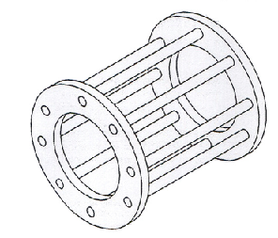

Figure 1- Squirrel cage rotor

The rotor has relatively large inductive reactance (XL) with respect to its resistance (R). Under these conditions the rotor current will lag the rotor voltage and the power factor in the circuit will be low.

One of the ways of creating a rotating electromagnet is to connect a three-phase power source to a stator made of three electromagnets A, B, and C, that are placed at 1200 to one another as shown in Figure 2.

When sine-wave currents phase shifted of 1200 to each other, like those shown in Figure 3

, flow in stator electromagnets A, B,and C, a magnetic field that rotates very regularly is obtained.

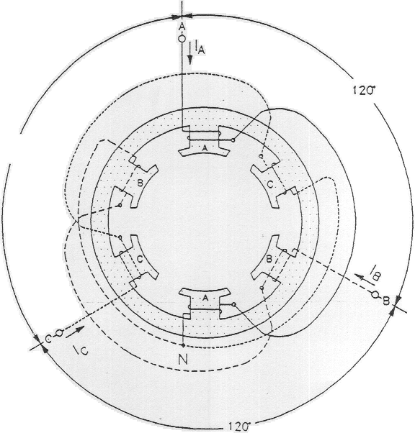

Figure 2

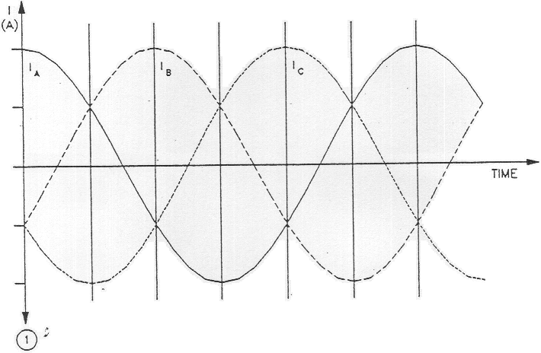

Figure 3

Figure 4, illustrates the magnetic field created by stator electromagnets A, B, and C at instants numbered 1 to 6 in Figure 3. Notice that the magnetic lines of force exit at the north pole of each electromagnet and enter at the South Pole. As can be seen, the magnetic field rotates clockwise.

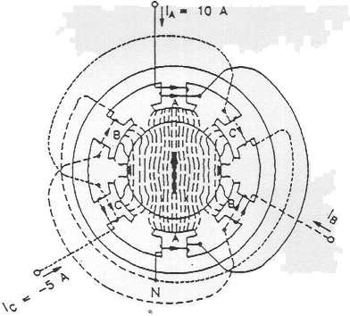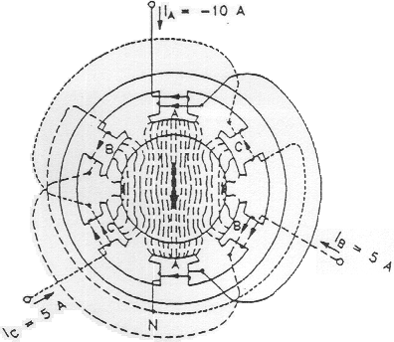

14

Figure 4

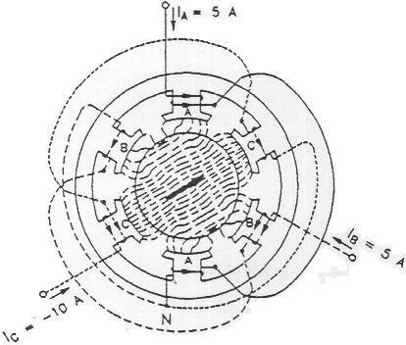 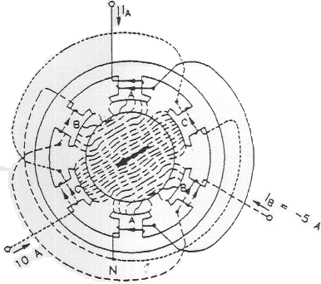

25

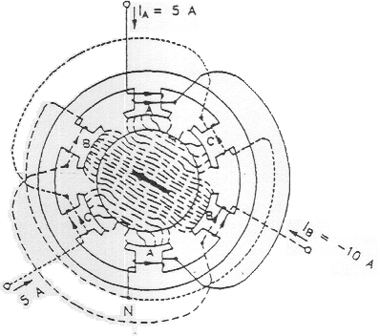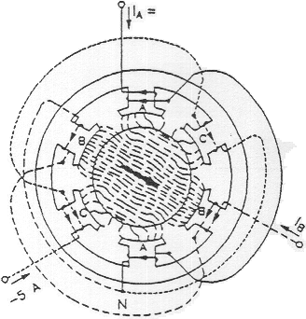

3 6

Figure 4

The use of sine-wave currents produces a magnetic field that rotates regularly and whose strength does not vary over time. The speed of the rotating magnetic field is known as the synchronous speed (ns and is proportional to the frequency of the ac power source. A rotating magnetic field can also be obtained using other combinations of sine-wave currents that are phase-shifted with respect to each other, but three-phase sine-wave currents are used more frequently.

When a squirrel-cage rotor is placed inside a rotating magnetic field, it is pulled around in the same direction as the rotating field. Interchanging the power connections to two of the stator windings (interchanging A with B for example) interchanges two of the three currents and reverses the phase sequence. This causes the rotating field to reverse direction. As a result, the direction of rotation of the motor is also reversed.

One can easily deduce that the torque produced by squirrel-cage induction motor increases as the difference in speed between the rotating magnetic field and the rotor increases. The difference in speed between the two is called slip. A plot of the speed versus torque characteristic for a squirrel-cage induction motor gives a curve similar to that shown in Figure 5. As can be seen, the motor speed (rotor speed) is always lower than the synchronous speed ns because slip is necessary for the motor to develop torque. The synchronous speed for the Lab-Volt motors is 1800 r/min for 60-Hz power, and 1500 r/min for 50-Hz power.

s = (( nsynch – nm) / nsynch) x 100 %

Where:

nsynch = Synchronous speed = (120 x fe) / P, P: number of poles.

nm = Rotor speed.

s = Slip.

The rotor frequency (fr )= s fe

Where:

fe : Electrical frequency.

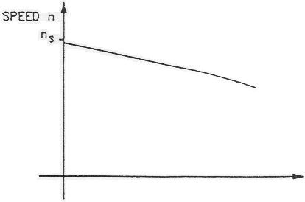τ (N.m)

Figure 5

The speed versus torque characteristic of the squirrel-cage induction motor is very similar to that obtained for a separately-excited dc motor. However, the currents induced in the squirrel-cage rotor must change direction more and more rapidly as the slip increases. In other words, the frequency of the currents induced in the rotor increases as the slip increases, since the rotor is made up of iron and coils of wire, it has an inductance that opposes rapid changes in current. As a result, the currents induced in the rotor are no longer directly proportional to the slip of the motor. This affects the speed versus torque characteristic as shown in figure 6.

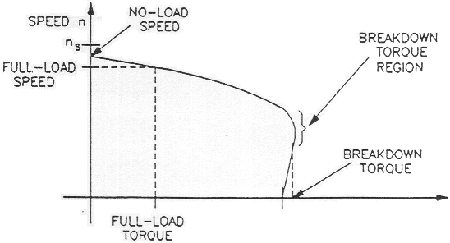τ (N.m)

Figure 6

As the curve shows, the no-load speed is slightly less than the synchronous speed ns, but as the load torque increases, motor speed decreases. For the nominal value of motor torque (full-load torque) corresponds a nominal operating speed (full-load speed). Further increases in load torque lead to a point of instability, called breakdown torque, after which both motor speed and output torque decrease. The torque value at zero speed, called locked-rotor torque, is often less than the breakdown torque. At start-up, and at low speed, motor current is very high and the amount of power that is consumed is higher than during normal operation.

Another characteristic of three-phase squirrel-cage induction motors is the fact that they always draw reactive power from the ac power source. The reactive power even exceeds the active power when the squirrel-cage induction motor rotates without load. The reactive power is necessary to create the magnetic field in the machine in the same way that an inductor needs reactive power to create the magnetic field surrounding the inductor.

As shown in figure 7 both locked rotor torque and the breakdown torque decrease greatly when the motor voltage is reduced. In practice, the torque decrease by factor equal to the square of the reduction factor of the motor voltage.

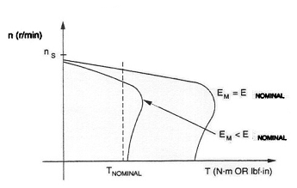

Figure 7

The efficiency of induction motor (ή) = Pout / Pin x 100 %

While Pout = τ ω

Where:

ω : Mechanical speed (rotor speed).  
 τ : Induced torque.

**Procedure:**

In the first part of the exercise, you will set up the equipment in the Workstation, connect the equipment as shown in Figure 8, and make the appropriate settings on the Prime Mover *I* Dynamometer.

In the second part of the exercise, you will apply the nominal line voltage to the squirrel-cage induction motor, note the motor direction of rotation, and measure the motor no-load speed. You will then increase the mechanical load applied to the squirrel-cage induction motor by steps. For each step, you will record in the data table various electrical and mechanical parameters related to the motor. You will then use this data to plot various graphs and determine many of the characteristics of the squirrel-cage induction motor.

In the third part of the exercise, you will interchange two of the leads that supply power to the squirrel-cage induction motor and observe if this affects the direction of rotation.

1. Install the Power Supply, Prime Mover / Dynamometer, Four-Pole Squirrel-Cage Induction Motor (Wye configuration), and Data Acquisition Interface {DAI) modules in the EMS workstation.
2. Mechanically couple the Prime Mover / Dynamometer to the Four-Pole Squirrel-Cage Induction Motor.
3. On the 'Power Supply, make sure the main power switch is set to the O (off) position, and the voltage control knob is turned fully counterclockwise.
4. Ensure that the flat cable from the computer is connected to the DAI module.
5. Connect the LOW POWER Inputs of the DAI and Prime Mover / Dynamometer modules to the 24 Vac output of the power supply. On the Power Supply, set the 24 V - AC power switch to the I (on) position
6. Start the Metering application. In the metering window open the set up.

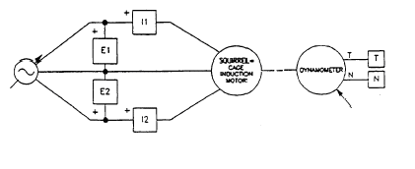

Figure 8

1. Set the Prime Mover / Dynamometer controls as follows:
   * MODE switch , DYN
   * LOAD CONTROL MODE switch MAN
   * LOAD CONTROL knob MIN (Fully ccw)
   * DISPLAY switch TORQUE (T)

**Characteristics of a Squirrel-Cage Induction Motor:**

1. Turn on the Power Supply and set the voltage control knob so that the line voltage indicated by meter E1 is equal to 400 line voltage of the squirrel-cage induction motor.
2. What is the direction of rotation of the squirrel-cage induction motor?
3. Record in the following blank space the motor speed indicated by meter N inthe Metering window.

n = …………………….. r/min

1. Is the no-load speed almost equal to the speed of the rotating magnetic field (synchronous speed) given in the Discussion?

YES NO

1. In the Metering window, make sure that the torque correction function of meter T is selected. Meter T indicates the output torque of the squirrel- cage induction motor.

On the Prime Mover / Dynamometer, adjust the LOAD CONTROL knob so that the mechanical power developed by the squirrel-cage induction motor (indicated by meter Pm in the Metering window) is equal to 175 W (nominal motor output power).

1. Record the nominal speed, torque, and line current of the squirrel-cage induction motor in the following blank spaces. The line current is

nNOM = r/min

TNOM = N.m (lbf.in)

INOM = A

On the Prime Mover / Dynamometer, turn the LOAD CONTROL knob fully counterclockwise. The torque indicated on the Prime Mover / Dynamometer display should be 0 N.m (0 Ibf.in).

1. Record the motor line voltage ELINE line current ILINE active power P, reactive power Q, speed n, output mechanical power Pm and output torque T (indicated by meters E1, I1, C, A, N, Pm and T, respectively) in the data table and table 2.
2. On the Prime Mover *I* Dynamometer, adjust the LOAD CONTROL knob so that the torque indicated on the module display increases by 0.3 N.m (3.0 Ibf.in) increments up to 1.8 N.m (15.0 Ibf.in). For each torque setting, record the data in the data table and table 2.
3. On the Prime Mover / Dynamometer, carefully adjust the LOAD CONTROL knob so that the torque indicated on the module display increases by 0.1 N.m (1.0 Ibf.in) increments until the motor speed starts to decrease fairly rapidly (breakdown torque region). For each additional torque setting, record the data in the data table. Once the motor speed has stabilized, record the data in the data table and table 2

|  |  |  |  |  |  |  |  |  |
| --- | --- | --- | --- | --- | --- | --- | --- | --- |
| **Eline**  **V** | **Iline**  **A** | **Pin**  **w** | **Q**  **VAR** | **n**  **rpm** | **Pm**  **w** | **τ**  **N.m** | **η**  **%** | **s**  **%** |
| **400** |  |  |  |  |  | **0** |  |  |
|  |  |  |  |  |  | **0.3** |  |  |
|  |  |  |  |  |  | **0.6** |  |  |
|  |  |  |  |  |  | **0.9** |  |  |
|  |  |  |  |  |  | **1.2** |  |  |
|  |  |  |  |  |  | **1.5** |  |  |
|  |  |  |  |  |  | **1.8** |  |  |
|  |  |  |  |  |  | **1.9** |  |  |
|  |  |  |  |  |  | **2.0** |  |  |
|  |  |  |  |  |  | **2.1** |  |  |
|  |  |  |  |  |  | **2.2** |  |  |

Table 2

1. When all data has been recorded, set the LOAD CONTROL knob on the Prime Mover / Dynamometer to the MIN. position (fully CCW), turn the voltage control knob fully counterclockwise, and turn off the Power Supply.

In the data table window, confirm that the data has been stored, edit the table so as to keep only the values of the motor line voltage ELINE line current ILINE active power P, reactive power Q, speed n, output mechanical power Pm and output torque T (data in columns E1, I1, C, A, N, Pm and T, respectively). Then calculate and record the efficiency (η) and the slip(s) in table 2.

1. Does the motor line current indicated in column I1 increase as the mechanical load applied to the squirrel-cage induction motor increases?

YES NO

1. In the Graph window, make the appropriate settings to obtain a graph of the motor .speed (obtained from meter N) as a function of the motor torque (obtained from meter N, name the x-axis as squirrel-Cage Induction-Motor Torque, name the y-axis as Squirrel-Cage Induction-Motor Speed, and print the graph.
2. Briefly describe how the speed varies as the mechanical load applied to the squirrel-cage induction increases i.e. as the motor torque increase.
3. Indicate on the graph the nominal speed and torque of the squirrel cage induction motor measured previously.

Using the graph,

* Determine the breakdown torque of the squirrel cage induction motor:

T BREAKDOWN = N.m (lbf.in)

* Determine the minimum-speed torque. This torque is a good approximation of the locked-rotor torque of the squirrel-cage induction motor

T LOCKED ROTOR = N.m (lbf.in)

1. Compare the breakdown torque and locked-rotor torque with the nominal torque of the squirrel-cage induction motor.
2. In the Graph window, make the appropriate settings to obtain a graph of the motor active (P) and reactive (Q) powers (obtained from meters C and A, respectively) as a function of the motor speed (obtained from meter N) using the data recorded previously in the data table, name the x-axis as Squirrel-Cage Induction-Motor Speed, name the y-axis as Squirrel-Cage Induction Motor Active and Reactive Powers, and print the graph.

* Does graph confirm that the squirrel-cage induction motor always draws reactive power from the ac power source?
* Does graph confirm that the squirrel-cage induction motor draws more electrical power from the ac power source as it drives a heavier load?
  + Observe that when the squirrel-cage induction motor rotates without load, the reactive power exceeds the active power. What does this reveal?

1. In the Graph window, make the appropriate settings to obtain a graph of the motor line current ILINE (obtained from meter I1) as a function of the motor speed (obtained from meter N) using the data recorded previously in the data table. Name the x-axis as Squirrel-Cage Induction-Motor Speed, name the y-axis as Squirrel-Cage Induction-Motor Line Current, and print the graph. How the line current does vary as the motor speed decreases?
2. Indicate on graph the nominal line current of the squirrel-cage induction motor measured previously.
3. How many times greater than the nominal line current is the starting line current (use the line current measured at minimum speed as the starting current)?
4. Adjust the line voltage Eline to 300 volt then repeat from step 14 to step 26 but on the Prime Mover / Dynamometer, carefully adjust the LOAD CONTROL knob so that the torque indicated on the module display increases by 0.1 N.m (1.0 Ibf.in) increments take the increment in the load torque

|  |  |  |  |  |  |  |  |  |
| --- | --- | --- | --- | --- | --- | --- | --- | --- |
| **Eline**  **V** | **Iline**  **A** | **Pin**  **w** | **Q**  **VAR** | **n**  **rpm** | **Pm**  **w** | **τ**  **N.m** | **η**  **%** | **s**  **%** |
| **300** |  |  |  |  |  | **0** |  |  |
|  |  |  |  |  |  | **0.1** |  |  |
|  |  |  |  |  |  | **0.2** |  |  |
|  |  |  |  |  |  | **0.3** |  |  |
|  |  |  |  |  |  | **0.4** |  |  |
|  |  |  |  |  |  | **0.5** |  |  |
|  |  |  |  |  |  | **0.6** |  |  |
|  |  |  |  |  |  | **0.7** |  |  |
|  |  |  |  |  |  | **0.8** |  |  |
|  |  |  |  |  |  | **0.9** |  |  |
|  |  |  |  |  |  | **1.0** |  |  |
|  |  |  |  |  |  | **1.1** |  |  |
|  |  |  |  |  |  | **1.2** |  |  |

Table 3

1. On the Four-Pole Squirrel-Cage Induction Motor, interchange any two of the three leads connected to- the stator windings.

Turn on the Power Supply and set the voltage control knob so that the line voltage indicated by meter E1 is approximately equal to the nominal line voltage of the squirrel-cage induction motor. What is the direction of rotation of the squirrel-cage induction motor?

1. Does the squirrel-cage induction motor rotate opposite to the direction noted previously in this exercise?
2. Turn the voltage control knob fully counterclockwise and turn off the Power Supply. Set the 24 V - AC power switch to the 0 (off) position, and remove all leads and cables.

**Note:**

Submit a Formal and group Laboratory Report.

# Department of Electrical Engineering

|  |  |
| --- | --- |
| **Faculty Member:____________________** | **Dated: ________________** |
| **Semester:__________________________** | **Section: ________________** |

**EE 260: Electro Mechanical System**

**Lab13: Shunt and Series Dc Motor Characteristics**

|  |  |  |  |  |
| --- | --- | --- | --- | --- |
| **Name** | **Reg. No** | **Report Marks / 10** | **Viva Marks / 5** | **Total/15** |
|  |  |  |  |  |
|  |  |  |  |  |
|  |  |  |  |  |
|  |  |  |  |  |

**Lab13: Shunt and Series Dc Motor Characteristics / P4**

**Objectives:**

**Conduct an experiment:**

* To learn the basic motor wiring connection.
* To observe the operating characteristics of shunt and series connected motors.
* To study the torque vs speed characteristics of a shunt and series motors.
* To calculate the efficiency of the shunt and series Dc motors.
* To observe the effect of varying the input voltage on the speed of the Dc shunt motor.

**Equipment:**

|  |  |  |  |
| --- | --- | --- | --- |
| **Sno.** | **Description** | **Module No.** | **Quantity** |
| 1 | Dc motor / generator | 8211 | 1 |
| 2 | Dc voltmeter / ammeter | 8412 | 1 |
| 3 | Power supply | 8821 | 1 |
| 4 | Hand tachometer | 8920 | 1 |
| 5 | Electrodynamometer | 8911 | 1 |
| 6 | Timing belt | 8942 | 1 |
| 7 | Connection leads | 8941 |  |

Table 1

**Discussion:**

Direct current motors are unsurpassed for variable speed applications, and for applications with severe torque requirements. Uncounted millions of fractional horsepower Dc motors are used by transportation industries in automobiles, trains and aircraft where they drive fans, blowers for air conditioners, heaters and defrosters; they operate windshield wipers, raise, lower seats and windows. One of their most useful functions is for the starting of gasoline and diesel engines in autos, trucks, buses and boats.

The Dc motor contains a stator and a rotor, the later commonly called an armature. The stator contains one or more windings per pole to setting up the magnetic field.

The armature and its winding are located in the path of this magnetic field and when the armature winding carries a current, a torque is developed causing the motor to turn.

**Shunt Dc motor:**

Dc shunt motor is a motor whose field circuit get’s its power directly across the armature terminals of the motor as shown in figure 1.

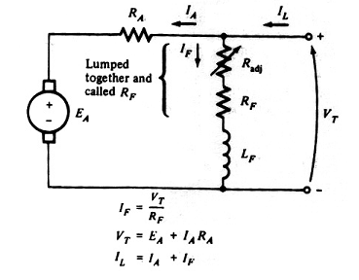

Figure 1- Dc shunt motor.

The speed of any Dc motor depends mainly on its armature voltage and the strength of the magnetic field. The speed tends to drop with load increasing on the motor due to the resistance of the armature winding. The following figure shows the speed-torque curve:

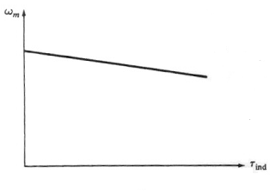

Figure 2- Torque-speed characteristic for Dc shunt motor.

Just like most energy conversion devices, the Dc shunt motor in not 100% efficient. In other words, all of the electric power which is supplied to the motor is not converted into mechanical power. The power difference between the input and the output is dissipated into form of heat, and constitutes what are known as the losses of the machine. These losses increase with load.

η = Pout/Pin

Where:

Pout = (2 x Л x n x τ)/ 60

Pin = Vin x Iin

**Series Dc motor:**

A series motor I a Dc motor whose field windings consists of few turns connected in series with the armature circuit. Figure 3 shows the Dc series motor equivalent circuit

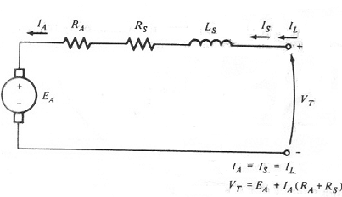

Figure 3- DC series motor.

In series motor the magnetic field produced by the same current which flows through the armature winding, with the result that the magnetic field weak when the load is light and strong when the load is heavy. Consequently the speed of the series connected motor is entirely determined by load current. The speed is low at heavy loads, and very high at no load. In fact if the series motor operated at no load it will run so fast which will damage the motor.

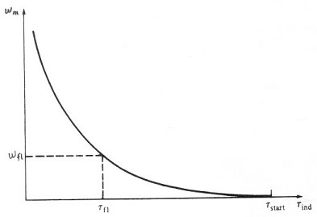

Figure 4- Torque-speed characteristics for Dc series motor.

The torque (τ = k x ф x IA) of any motor depends on the product of armature current and the magnetic field. For series connected motor this relationship implies that the torque will be very large for high armature currents, such as occur during start up. The series motor is adapted to start large heavy loads.

**Procedure:**

**Warring: high voltages are presented in this laboratory experiment! Do not make any connections with the power on! The power should be turned off after completing each individual measurement!**

**Shunt motor:**

1. Using your power supply, Dc motor / generator, Dc voltmeter / ammeter and electrodynamometer set up the circuit in figure 5.

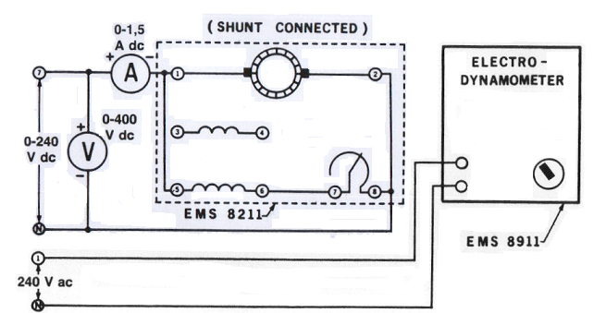

Figure 5- Shunt motor.

Notice that the motor is wired for shunt field operation and is connected to the variable Dc output of the power supply (terminals 7 and N). The electrodynamometer is connected to fix 240 V Ac output of the power supply (terminals 1 and N).

Couple the electrodynamometer to the Dc motor / generator with the timing belt.

1. Set the shunt rheostat control knob at its full cw position (for maximum shunt field excitation).
2. Set the electrodynamometer control knob at its ccw position (to provide minimum starting load for the Dc motor).
3. Turn on the power supply. Adjust the variable input to 240 V Dc as indicated by the voltmeter. **Not the direction of rotation: if it is not cw turn off the power supply and interchange the shunt field connection.**
4. a. Adjust the shunt filed rheostat for no load motor speed of 1500 rpm as indicated on your hand tachometer. Make sure the voltmeter connected across the input of your circuit indicates exactly 240 V Dc.

b. Measure and record in table 2 the line current as indicated by the Dc ammeter for motor speed 1500 rpm.

c. Apply a load to the Dc motor / generator by varying the electrodynamometer control knob until the scale marker on the stator housing indicates 0.2 N.m( readjust the power supply, if necessary to maintain exactly 240 V Dc).

d. Measure and record the line current and the motor speed in table 2.

e. Repeat for each of the torque values listed in table 2 while maintaining a constant 240 V Dc.

f. Return the voltage to zero and turn off the power supply.

|  |  |  |  |  |  |  |
| --- | --- | --- | --- | --- | --- | --- |
| **E**  **V** | **I**  **A** | **Speed**  **rpm** | **Torque**  **N.m** | **Pin**  **w** | **Pout**  **w** | **η** |
| **240** |  |  | **0** |  |  |  |
| **240** |  |  | **0.2** |  |  |  |
| **240** |  |  | **0.4** |  |  |  |
| **240** |  |  | **0.6** |  |  |  |
| **240** |  |  | **0.8** |  |  |  |
| **240** |  |  | **1.0** |  |  |  |
| **240** |  |  | **1.2** |  |  |  |

Table 2

1. Calculate and record in table 2 Pin, Pout and the efficiency for the shunt Dc motor.
2. Draw the motor speed chrematistics curve values from table 2.
3. a. Set the electrodynamometer control knob at its cw position( to provide the maximum starting load for the shunt wound motor)

b. Turn on the power supply and gradually increase the dc voltage until the motor is drawing 1.5 A of line current. The motor should turn slowly or not at all.

c. Measure and record the Dc voltage and torque developed

E = ………………. V τ = ………………... N.m

d. Return the voltage to zero and turn off the power supply

1. a. The line current in step 8 is limited only by the equivalent Dc resistance of the shunt wound motor

b. Calculate the value of the starting current if the full line voltage (240 V Dc) were applied to the shunt wound motor

Starting current = ……………… A

1. a. Adjust the input Dc voltage to 100 V Dc.

b. Set the load on the electrodynamometer to 0.8 N.m and this load constant.

c. Set the shunt rheostat control knob at its full cw position (for maximum shunt field excitation).

1. a. Measure and record in table 3 the input voltage.

b. Increase the speed at 100 rpm by varying the input voltage then record in table 3 the input voltage

c. Repeat step 11.b until reach the input voltage 240 V Dc.

|  |  |  |
| --- | --- | --- |
| **τ**  **N.m** | **Voltage**  **V** | **Speed**  **rpm** |
| **0.8** | **100** |  |
| **0.8** |  |  |
| **0.8** |  |  |
| **0.8** |  |  |
| **0.8** |  |  |
| **0.8** | **240** |  |

Table 3

**Series motor:**

1. Connect the circuit in figure 6.

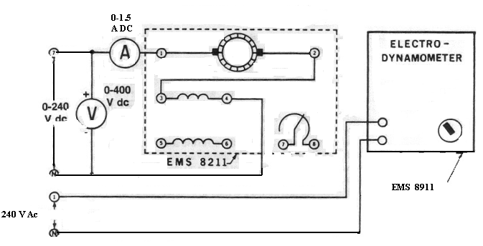

Figure 6- Series Motor.

Notice that the motor is wired for series field operation and is connected to the variable Dc output of the power supply (terminals 7 and N). The electrodynamometer is connected to fix 240 V Ac output of the power supply (terminals 1 and N).

Couple the electrodynamometer to the Dc motor / generator with the timing belt.

1. Set the electrodynamometer control knob at its mid range position (to provide a starting load for the Dc motor).
2. a. Turn on the power supply. Gradually increase the Dc voltage until the motor starts to run. **Not the direction of rotation: if it is not cw turn off the power supply and interchange the series field connection.**

b. Adjust the variable voltage for exactly 240 V Dc as indicated by the voltmeter.

1. a. adjust the loading of your dc series motor by varying the electrodynamometer control knob until the scaled marked on the stator housing indicates 1.6 N.m ( readjust the power supply if necessary to maintain the exactly 240 V Dc).

b. Measure the line current and the motor speed (use hand tachometer). Record these values in table 4

c. Repeat for each of torque values listed in the table while maintaining a constant 240 V Dc input.

d. Return the voltage to zero and turn off the power supply.

|  |  |  |  |  |  |  |
| --- | --- | --- | --- | --- | --- | --- |
| **E**  **V** | **I**  **A** | **Speed**  **rpm** | **Torque**  **N.m** | **Pin**  **w** | **Pout**  **w** | **η** |
| **240** |  |  | **0.6** |  |  |  |
| **240** |  |  | **0.8** |  |  |  |
| **240** |  |  | **1.0** |  |  |  |
| **240** |  |  | **1.2** |  |  |  |
| **240** |  |  | **1.4** |  |  |  |
| **240** |  |  | **1.6** |  |  |  |

Table 4

1. Calculate and record in table 4 Pin, Pout and the efficiency for the series Dc motor.
2. Draw the motor speed chrematistics curve values from table 4
3. a. Set the electrodynamometer control knob at its full cw position( to provide the maximum starting load for the series wound motor)

b. Turn on the power supply and gradually increase the dc voltage until the motor is drawing 1.5 A of line current. The motor should turn slowly.

c. Measure and record the Dc voltage and torque developed

E = ………………. V τ = ………………... N.m

d. Return the voltage to zero and turn off the power supply

1. a. The line current in step 18 is limited only by the equivalent Dc resistance of the series motor

b. Calculate the value of the starting current if the full line voltage (240 V Dc) were applied to the series wound motor

Starting current = ……………… A

**Note**:

1. Submit group Laboratory Report.

# Department of Electrical Engineering

|  |  |
| --- | --- |
| **Faculty Member:____________________** | **Dated: ________________** |
| **Semester:__________________________** | **Section: ________________** |

**EE 260: Electro Mechanical System**

**Lab14: Operating Characteristics for An Asynchronous Generator (Eddy Current Brake)**

|  |  |  |  |  |
| --- | --- | --- | --- | --- |
| **Name** | **Reg. No** | **Report Marks / 10** | **Viva Marks / 5** | **Total/15** |
|  |  |  |  |  |
|  |  |  |  |  |
|  |  |  |  |  |
|  |  |  |  |  |

**Lab14: Operating Characteristics for An Asynchronous Generator (Eddy Current Brake) / P4**

**OBJECTIVE:**

**Conduct an experiment:**

Using Data Acquisition Interface (DAI):

* Demonstrate the main operating characteristics of an eddy-current brake as well as of an asynchronous generator using the Four-Pole Squirrel-Cage Induction Motor and Prime Mover / Dynamometer modules.

**EQUIPMENT:**

|  |  |  |
| --- | --- | --- |
| **Description** | **Module No.** | **Quantity** |
| Four Pole Squirrel – Cage Induction Motor | 8221 | 1 |
| Data Acquisition Interface (DAI) | 9061 | 1 |
| Prime Mover/ Dynamometer | 8960 | 1 |
| Resistive load | 8311 | 1 |
| Connecting Leads Set | 8941 | 1 |
| Timing Belt | 8942 | 1 |
| Power Supply | 8821 | 1 |

Table 1

**DISCUSION:**

Figure 1, illustrates the magnet and the conducting ladder, however, the magnet is fixed and the ladder is displaced rapidly towards right.

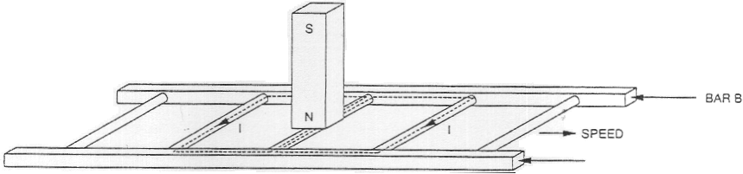

Figure 1

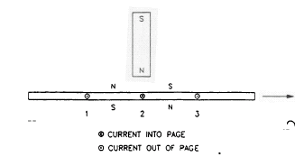

Figure 2

This causes current to flow in the loop formed by conductors 1 and 2, as 'Nell as in the loop formed by conductors 2 and 3. These currents create magnetic fields with north and south poles as shown in Figure 2.

The interaction between the magnetic field of the magnet and the magnetic fields produced by the currents induced in the ladder creates a force between the fixed magnet and the moving electromagnet (the conducting ladder). This force causes the ladder to be pulled along in the direction of the fixed magnet, and thereby, tends to reduce the ladder speed. However, if the ladder stops moving, there is no longer a variation in the magnetic flux. Consequently, there is no induced voltage to cause current flow in the wire loops, meaning that there is no longer magnetic force acting on the ladder. Therefore; a magnetic braking force acts on the ladder as long as it is moving. The greater the ladder speed (up to a certain limit), the greater the variation in magnetic flux, and therefore, the greater the magnetic braking force acting on the conducting ladder.

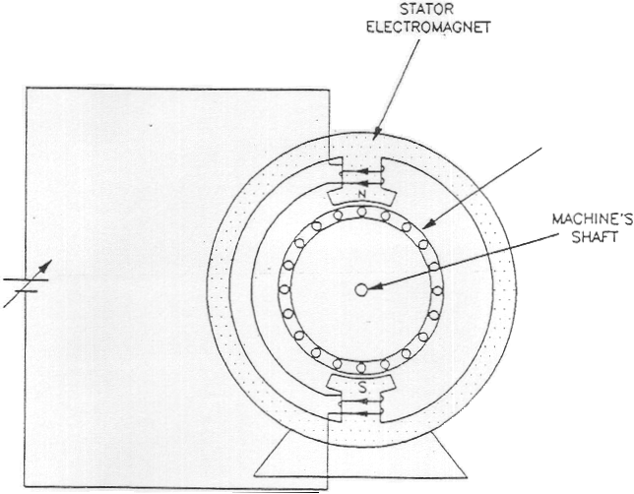The above principle is used to advantage in the eddy current brake, in which a fixed (stator) electromagnet creates a braking torque that acts on a squirrel-cage rotor obtained by closing a ladder similar to that shown in Figure 3 itself. Figure 3 illustrates an eddy-current brake. Notice that a variable-voltage dc source is used to make current flow in the stator electromagnet. Varying the dc source voltage allows variation of the current in the electromagnet, and thereby, variation of the electromagnet strength. The greater the electromagnet strength, the greater the magnetic flux in the machine, the greater the currents induced in the squirrel-cage rotor as it turns, and the greater the braking force.

Note that mechanical energy from the driving machine is transferred to the eddy- current brake during braking. This energy is converted to electrical energy that is dissipated as heat in the squirrel-cage rotor of the eddy-current brake.

**Figure 3**

Figure 3

A braking force like that in eddy-current brake can be produced in squirrel-cage induction motors. This occurs when the rotor rotates at a speed higher than that of the rotating magnetic field (synchronous speed ns). This is equivalent to having a fixed magnet and a moving ladder as in Figure 1. As in the eddy-current brake, mechanical energy is converted to electrical energy when the speed of a squirrel-cage induction motor is higher than the synchronous speed ns. However, most of this energy is not dissipated as heat in the rotor of the squirrel-cage induction motor. It is returned to the ac power source connected to the stator windings of the motor. Therefore a squirrel-cage induction motor operates as an asynchronous generator when its speed is higher than the synchronous speed ns.

In brief, when the rotor of a squirrel-cage induction machine rotates slower than the synchronous speed, the machine operates as a motor because the interaction of the magnetic fields in the machine creates a force that tends to increase the rotor speed. Conversely, when the rotor turns at a speed higher than the synchronous speed, the interaction of the magnetic fields creates a force that tends to slow down the motor, and thus, the machine operates as an asynchronous generator. Figure 4 illustrates the two cases.

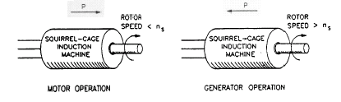

Figure 4

A particularity of the squirrel-cage induction machine is that it always requires reactive power to operate. The reactive power is needed to create the rotating magnetic field that is essential whether the machine operates as a motor or a generator. If the rotor of a squirrel-cage motor is turned without the motor being connected to an ac source, no output voltage is generated. This is because no induced current flows in the rotor. In order for the squirrel-cage induction machine to operate as an asynchronous generator, it must be connected to an ac source to obtain the reactive power necessary for the rotating magnetic field. The speed versus torque characteristic shown in Figure 5 illustrates both motor and generator operation of a squirrel-cage induction machine.

In brief, when the rotor of a squirrel-cage induction machine rotates slower than the synchronous speed, the machine operates as a motor because the interaction of the magnetic fields in the machine creates a force that tends to increase the rotor speed. Conversely, when the rotor turns at a speed higher than the synchronous speed, the interaction of the magnetic fields creates a force that tends to slow down the motor, and thus, the machine operates as an asynchronous generator. Figure 4 illustrates the two cases.

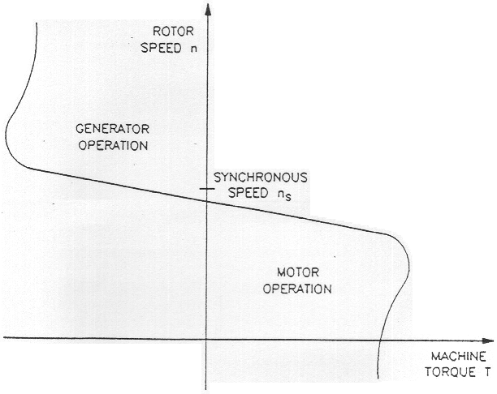

Figure 5

**PROCEDURE:**

**Warning: *High voltages are present in this Laboratory Experiment! You must ask the instructor to check your connections before turn the power on! The power should be turned off after completing each individual measurement!***

In the first part of the exercise, you will set up the equipment in the Workstation, connect the equipment as shown in Figure 6, and make the appropriate settings on the Prime Mover / Dynamometer.

In the second part of the exercise, you will demonstrate eddy-current braking. An eddy-current brake will be implemented by connecting one of the stator winding of the Four-Pole Squirrel-Cage Induction Motor to a dc power source through a resistive load. Varying the value of the resistive load will allow variation of the electromagnet current, and thereby, variation of the braking torque.

In the third part of the exercise, you will observe the operation of a squirrel-cage induction motor operating as an asynchronous generator.

1. Install the Power Supply, Prime Mover / Dynamometer, Four-Pole Squirrel-Cage Induction Motor, Resistive Load, and Data Acquisition Interface (DAI) modules in the EMS workstation.
2. Mechanically couple the Prime Mover / Dynamometer to the Four-Pole Squirrel-Cage Induction Motor.
3. On the Power Supply, make sure the main power switch is set to the 0 (off) position, and the voltage control knob is turned fully counterclockwise. Ensure the Power Supply is connected to a three-phase power source
4. Ensure that the flat cable from the computer is connected to the DAI module. Connect the LOW POWER Inputs of the DAI and Prime Mover / Dynamometer modules to the 24 V - AC output of the Power Supply.

On the Power Supply, set the 24 V - AC power switch to the I (on) position.

1. Start the Metering application, In the Metering window, open setup configuration.
2. Connect the equipment as shown in Figure 6. Connect the three resistor sections on the Resistive Load module in parallel to implement resistor R1.
3. Set the Prime Mover / Dynamometer controls as follows:

MODE switch PRIM MOVER (P.M)

DISPLAY switch SPEED (N)

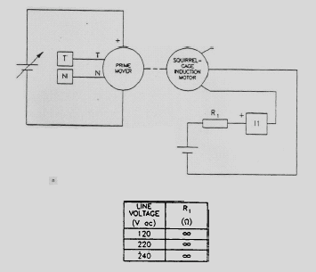Figure 6

**Demonstrating Eddy-Current Braking**

1. Turn on the Power Supply and set the voltage control knob so that the Prime Mover rotates at a speed of 150 r/min. In the Metering window, set meter I1 in the dc mode and make sure that the torque correction function of meter T is selected. Meter T now indicates the braking torque TBAKING caused by the squirrel-cage Induction motor.

Record the Prime Mover speed n, the electromagnet current IEM (Indicated by meter I1), the braking torque T BRAKING and the direction of rotation in the following blank spaces.

n = r/min

IEM = A

TBRAKING = N.m (lbf.in)

Direction of rotation =

1. Close the switches on the Resistive Load module one at a time to increase the current in the stator electromagnet by steps. While doing this, observe the speed and torque indicated in the Metering window.
2. When all switches are closed, record the Prime Mover speed n, the electromagnet current IEM the braking torque TBRAKING and the direction of rotation in the following blank spaces.

n = r/min

IEM = A

TBRAKING = N.m (lbf.in)

Direction of rotation =

Turn off the Power Supply.

1. Describe how the braking torque varies when the electromagnet current is increased.
2. Do the results demonstrate that the squirrel-cage induction motor operate as an eddy-current brake?
3. On the Prime Mover / Dynamometer, reverse the connection of the leads at the PRIME MOVER INPUT. On the Resistive Load module, make the appropriate settings so that the resistance value of resistor R1 is infinite. Turn on the Power Supply and slightly adjust the voltage control knob so that the Prime Mover rotates at a speed of 150 r/min.

Record the Prime Mover speed n, the electromagnet current IEM the braking torque T BRAKING and the direction of rotation in the following blank spaces.

n = r/min

IEM = A

T BRAKING = N.m (lbf.in)

Direction of rotation =

1. Close the switches on the Resistive Load module one at a time to increase the current in the stator electromagnet by steps. While doing this, observe the speed and torque indicated in the Metering window.

When all switches are closed, record the Prime Mover speed n, the electromagnet current IEM, the braking torque T BRAKING and the direction ofrotation in the following blank spaces.

n = r/min

IEM = A

T BRAKING = N.m (lbf.in)

Direction of rotation =

1. Turn the voltage control knob fully counterclockwise and turn off the Power Supply.
2. Describe how the braking torque varies when the electromagnet current is increased.
3. Is the operation of the squirrel cage induction motor affected by the direction of rotation of the Prime Mover?

**Asynchronous Generator Operation**

1. Modify the connections so that the equipment is connected as shown in Figure 7. Do not connect lines A, B, and C of the three-phase power source to the circuit at this time.

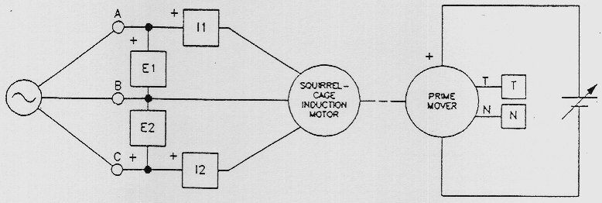

Figure 7

1. Turn on the Power Supply and set the voltage control knob so that the Prime Mover rotates clockwise at a speed of 1200 r/min.
2. Turn off the Power Supply without modifying the setting of the voltage control knob.
3. Connect lines A, B, and C of the three-phase power source to the circuit as shown in Figure 7.

Set the Prime Mover / Dynamometer controls as follows:

MODE switch DYN

LOAD CONTROL MODE switch MAN

LOAD CONTROL knob MIN (fully ccw)

DISPLAY switch TORQUE (T)

In the Metering window, set meter I1 in the ac mode and select a zero- centre analog-type display and the 750-W scale for meters C and Pm.

1. Turn on the Power Supply and verify that the squirrel-cage induction machine rotates clockwise.
2. On the Prime Mover / Dynamometer, set the LOAD CONTROL knob so that the torque indicated on the module display is 1.0 N.m (9.0 lbf-in).

Record in the following blank spaces the squirrel-cage induction machine active power P, reactive power Q, mechanical power Pm, speed n torque T (indicated by meters C, A, and Pm, N, and, T, respectively).

P = W, Q = Vars

Pm = W, .n = r/min

T = N.m

Does active power flow from the ac power source to the squirrel-cage induction machine?

What does this indicate about the operation of the squirrel-cage induction machine?

1. On the Prime Mover / Dynamometer, slowly turn LOAD CONTROL knob fully counterclockwise then set the MODE switch to the PRIME MOVER (P.M.) position. While doing this, observe the. Squirrel-cage induction machine active power P, reactive power Q, and mechanical power Pm.

On the Power Supply, turn the voltage control knob clockwise until the machines rotate at the synchronous speed of the Four-Pole Squirrel-Cage Induction Motor.

Record in the following blank spaces the squirrel-cage induction machine active power P, reactive power Q, mechanical power Pm, speed n, and torque T (indicated by meters C, A, Pm, N, and, T, respectively).

P = W, Q = Vars

Pm = W, .n = r/min

T = N.m

Does a significant amount of active power flow between the ac power source and the squirrel-cage induction machine?

1. On the Power Supply, slowly set the voltage control knob so that the machines *rotate* at 105% of the synchronous speed of the Four-Pole Squirrel-Cage Induction Motor.

Record in the following blank spaces the squirrel-cage induction machine active power P, reactive power Q, mechanical power Pm, speed n, and torque T (indicated by meters C, A, Pm, N, and, T, respectively).

P = W, Q = Vars

Pm = W, .n = r/min

T = N.m

Does active power flow from the squirrel-cage induction machine to the ac power source?

What does this indicate about the operation of the squirrel-cage induction machine?

1. Turn offthe Power Supply and turn the voltage control knob fully counterclockwise. Disconnect the three-phase power source from the circuit at points A B, and C shown in Figure7.

.

1. Turn on the Power Supply and set the voltage control knob so that the Prime Mover rotates at a speed of approximately 1000 r/min.

Record the line voltage generated by the asynchronous generator (indicated by meter E1).

ELINE = V

Does this confirm that generator operation is not possible unless the squirrel-cage induction machine is connected to the three-phase ac power network?

1. Turn the voltage control knob fully counterclockwise and turn off the Power Supply. Set the 24 V - AC power switch to the 0 (off) position, and remove all leads and cables.

# Department of Electrical Engineering

|  |  |
| --- | --- |
| **Faculty Member:____________________** | **Dated: ________________** |
| **Semester:__________________________** | **Section: ________________** |

**EE 260: Electro Mechanical System**

**Lab15: Operating Characteristics of Universal Motor**

|  |  |  |  |  |
| --- | --- | --- | --- | --- |
| **Name** | **Reg. No** | **Report Marks / 10** | **Viva Marks / 5** | **Total/15** |
|  |  |  |  |  |
|  |  |  |  |  |
|  |  |  |  |  |
|  |  |  |  |  |

**Lab15: Operating Characteristics of Universal Motor / P4**

**OBJECTIVE:**

**Conduct an experiment:**

To demonstrate the main operating characteristics of an Universal Motor using Data Acquisition Interface (DAI) and Prime Mover / Dynamometer modules.

**EQUIPMENT:**

|  |  |  |
| --- | --- | --- |
| **Description** | **Module No.** | **Quantity** |
| Ems Workstation | 8134 | 1 |
| Data Acquisition Interface (DAI) | 9061 | 1 |
| Prime Mover/ Dynamometer | 8960 | 1 |
| Connecting Leads Set | 8941 | 1 |
| Timing Belt | 8942 | 1 |
| Power Supply | 8821 | 1 |

Table 1

**DISCUSSION**

You saw in Unit 2 that the armature winding creates a rotating magnetic field in the rotor of a dc motor. This magnetic field rotates at the same speed as the motor but in the opposite direction. As a result, the poles of the rotor electromagnet remain at a fixed location. Furthermore, the poles of the rotor electromagnet are always at 90° to the poles of the stator magnet or electromagnet (field electromagnet) as was illustrated in Figure 2-5.

However, if either the polarity of the stator electromagnet or that of the rotor electromagnet is reversed, the motor direction of rotation is reversed because the forces of attraction and repulsion between the two magnets are reversed. Figure 3-9 illustrates the different possibilities when the polarities of the armature current IA and field current IF are changed. When currents IA and IF are of the same polarity, the motor rotates clockwise. Conversely, when currents IA and IF are of opposite polarity, it rotates counterclockwise.

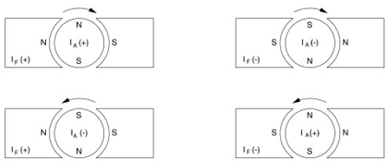

**Figure 3-9. Direction of Rotation Depends on the Polarities of the Armature and Field Currents.**

When both the armature and the field electromagnet of a dc motor are powered from the same source, which is the case for shunt and series motors, reversing the polarity of the voltage source reverses the polarity of both the armature and field currents. Consequently, the torque does not change direction when the polarity of the voltage applied to the motor changes. Therefore, shunt and series dc motors rotate when connected to an ac power source despite the fact that the source voltage polarity is constantly changing.

However, since motors are made of windings and iron, they always have inductance associated with their windings. For example, the field winding of a shunt motor usually has a large inductance value because it consists of many turns of wire. This makes it difficult for alternating current to flow in the winding because a large

Inductance means high impedance. For this reason, it is almost impossible to obtain satisfactory performance from a shunt motor connected to an ac power source.

A series motor has a field winding that consists of only a few turns of wire. Consequently, the field winding of the series motor has a low inductance. Its impedance is therefore much lower than that of the shunt winding, and the series motor operates on ac power with better results than a shunt motor. However, the performance obtained with ac power is naturally much poorer than that obtained when the series motor is connected to a dc power source.

The performance of a series motor operating with ac power can be greatly improved by decreasing the inductance of the armature winding. This can be done by adding a new winding, called compensating winding, to the series motor. This winding is installed in the stator slots and the armature current flows through the winding. The wire loops of the compensating winding are connected so that the direction of current flow in each loop is opposite to the direction of current flow in the corresponding armature loop lying next to it, as illustrated in Figure 3-10.

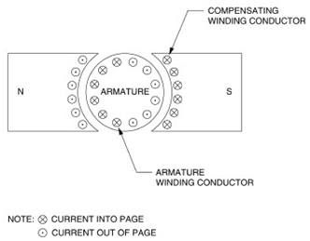

**Figure 3-10. Current flow in the Compensating Winding.**

This is equivalent to winding the coil of an inductor with ten turns of wire in one direction, and then ten turns of wire in the opposite direction. The resulting inductor has a very small inductance because of the cancelling effect caused by equal number of coils being wound in opposite directions. This new type of series motor is known as a universal motor because it can operate indifferently on ac power, as well as dc power.

**Procedure Summary**

In the first part of the exercise, you will set up the equipment in the Workstation, connect the equipment as shown in Figure 3-11, and make the appropriate settings on the equipment.

In the second part of the exercise, you will change the polarities of the armature and field currents of a series motor operating on dc power and observe the effect on the direction of rotation. You will also measure the dc voltage required to make the series motor rotate at a speed of approximately 1000 r/min.

In the third part of the exercise, you will replace the dc power source with an ac power source. You will observe that the direction of rotation of the series motor can be changed by reversing the armature connections. You will measure the ac source voltage required to make the series motor rotate at a speed of approximately 1000 r/min. You will measure the armature impedance ZA. You will compare the series motor performance obtained with dc power and ac power.

In the fourth part of the exercise, you will modify the connections to obtain the universal motor circuit shown in Figure 3-12. You will change the polarities of the armature and field currents of the universal motor operating on dc power and observe the effect on the direction of rotation. You will also measure the dc voltage required to make the universal motor rotate at a speed of approximately 1000 r/min.

In the fifth part of the exercise, you will replace the dc power source with an ac power source. You will observe that the direction of rotation of the universal motor can be changed by reversing the armature connections. You will measure the ac source voltage required to make the universal motor rotate at a speed of approximately 1000 r/min. You will measure the armature impedance ZA. You will compare the universal motor performance obtained with dc power and ac power. You will compare the performance of the universal motor to that of the series motor.

In the sixth part of the exercise, you will add a compensating winding to the universal motor. You will observe the effect on the performance of the universal motor operating on ac power.

**Equipment Required**

Refer to the Equipment Utilization Chart in Appendix C to obtain the list of equipment required for this exercise.

**Procedure**

|  |
| --- |
| ***CAUTION!***  ***High voltages are present in this laboratory exercise! Do not make or modify any banana jack connections with the power on unless otherwise specified!*** |

**Setting up the Equipment**

1. Install the Power supply Prime Mover/Dynamometer, DC Motor/Generator, Universal Motor and DAI Module in the EMS workstation.

|  |
| --- |
| ***Note: If you are performing the exercise using the EMS system, ensure that the brushes of the DC Motor / Generator are adjusted to the neutral point. To do so, connect an ac power source (terminals 4 and N of the Power Supply) to the armature of the DC Motor / Generator (terminals 1 and 2) through CURRENT INPUT I1 of the data acquisition module. Connect the shunt winding of the DC Motor / Generator (terminals 5 and 6) to VOLTAGE INPUT E1 of the Data Acquisition Interface module. Start the Metering application and open setup configuration file ACMOTOR1.DAI. Turn the Power Supply on and set the voltage control knob so that an ac current (indicated by meter I line 1) equal to half the nominal value of the armature current flows in the armature of the DC Motor / Generator. Adjust the brush adjustment lever on the DC Motor / Generator so that the voltage across the shunt winding (indicated by meter E line 1) is minimum. Turn the Power Supply off, exit the Metering application, and disconnect all leads and cable.***  ***Also, ensure that the brushes of the Universal Motor are adjusted to the neutral point. To do so, repeat the above procedure, connecting the series winding of the Universal Motor to VOLTAGE INPUT E1 of the data acquisition module.*** |

Mechanically couple the prime mover / dynamometer module to the DC Motor / Generator using a timing belt.

2. On the Power Supply, make sure the main power switch is set to the O (off) position, and the voltage control knob is turned fully counterclockwise. Ensure the Power Supply is connected to a three-phase power source.

3. Ensure that the data acquisition module is connected to a USB port of the computer. Connect the POWER INPUT of the data acquisition module to the 24 V AC output of the Power Supply.

4. Start the Metering application.In the Metering window, open setup configuration file DCMOTOR1.DAI then select meter layout 2.

5. Set up the series motor circuit shown in Figure 3-11.

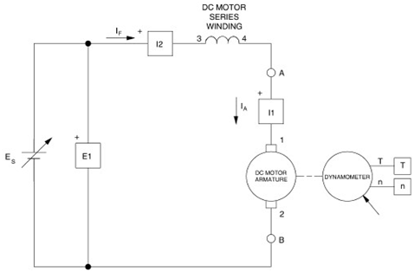

**Figure 3-11. Series Motor Coupled to a Dynamometer.**

6. Set the Prime Mover/Dynamometer control as follow.

MODE switch DYN

LOAD CONTROL MODE switch MAN

LOAD CONTROL knob MIN (Fully CCW)

DISPLAY switch SPEED (N)

**Direction of Rotation of a DC Series Motor**

7. Turn the Power Supply on and slowly turn the voltage control knob until the series motor rotates at a speed of 1000 r/min ± 25 r/min. Check that both the armature current IA and the field current IF [indicated by meters I1 (IA) and I2 (IF), respectively] are positive. Record the source voltage ES [indicated by meter E 1. (EA)] And the direction of rotation.

ES = V

Direction of rotation:  (IA and IF = positive)

Turn the Power Supply off.

8. On the Power Supply, reverse the connection of the leads at terminals 7 and N to reverse the polarity of the voltage applied to the series motor.

Turn the Power Supply on and slightly adjust the voltage control knob until the series motor rotates at a speed of 1000 r/min ± 25 r/min. Check that both the armature current IA and the field current IF are negative. Record the source voltage ES [indicated by meter E 1. (EA)] and the direction of rotation.

ES =  V

Direction of rotation:  (IA = and IF = negative)

Turn the Power Supply off.

What is the direction of rotation when the armature current IA and the field current IF are of the same polarity?



9. Reverse the armature connection at points A and B shown in Figure 3-11.

Turn the Power Supply on and slightly adjust the voltage control knob until the series motor rotates at a speed of 1000 r/min ± 25 r/min.

|  |
| --- |
| ***Note: Neglect the sign of the speed indicated by the Speed meter in the Metering window.*** |

Check that the armature current IA is positive and the field current IF is negative. Record the source voltage ES and the direction of rotation.

ES = V

Direction of rotation:  (IA = positive, IF = negative)

Turn the Power Supply off.

10. On the Power Supply, reverse the connection of the leads at terminals 7 and N to reverse the polarity of the voltage applied to the series motor.

Turn the Power Supply on and slightly adjust the voltage control knob until the series motor rotates at a speed of 1000 r/min ± 25 r/min.

|  |
| --- |
| ***Note: Neglect the sign of the speed indicated by the Speed meter in the Metering window.*** |

Check that the armature current IA is negative and the field current IF is positive. Record the source voltage ES and the direction of rotation.

ES = V

Direction of rotation:  (IA = negative, IF = positive)

Turn the voltage control knob fully counterclockwise and turn the Power Supply off.

What is the direction of rotation when the armature current IA and the field current IF are of opposite polarity?



Reverse the armature connection at points A and B shown in Figure 3-11.

The modules should be connected as shown in Figure 3-11.

**DC Series Motor Operating on AC Power**

11. Replace the variable-voltage dc source in the circuit with a variable-voltage ac source.

In the Metering window, set meters E 1 (EA), I1 (IA), and I2 (IF) in the ac mode.

Turn the Power Supply on and slowly turn the voltage control knob until the series motor rotates at a speed of 1000 r/min ± 25 r/min. Record the source voltage ES [indicated by meter E 1 (EA)] and the direction of rotation.

ES = V

Direction of rotation:  (IA and IF of the same polarity)

Does the series motor rotate in the same direction as when it was operating on dc power with IA and IF of the same polarity (steps 7 and 8)?

Yes No

Turn the Power Supply off.

12. Reverse the armature connection at points A and B shown in Figure 3-11.

Turn the Power Supply on and slightly adjust the voltage control knob until the series motor rotates at a speed of 1000 r/min ± 25 r/min.

|  |
| --- |
| ***Note: Neglect the sign of the speed indicated by the Speed meter in the Metering window.*** |

Record the source voltage ES and the direction of rotation.

ES = V

Direction of rotation:  (IA and IF of opposite polarity)

Does the series motor rotate in the same direction as when it was operating on dc power with IA and IF of opposite polarity (steps 9 and 10)?

Yes No

13. On the Power Supply, slowly turn the voltage control knob until the series motor stops rotating.

In the Metering window, set meter RA = EA / IA so that it measures impedance (Z).

Record in the following blank space the armature impedance ZA of the series motor indicated by the impedance meter.

ZA =Ω

Turn the voltage control knob fully counterclockwise and turn the Power Supply off.

Compare the dc and ac source voltages ES required to make the series motor rotate at a speed of approximately 1000 r/min. briefly explain why they have different values.







**Direction of Rotation of a Universal Motor Operating on DC Power**

14. Remove the timing belt which couples the prime mover / dynamometer module to the DC Motor / Generator.

Mechanically couple the prime mover / dynamometer module to the Universal Motor using a timing belt.

Modify the connections to obtain the universal-motor circuit shown in Figure 3-12.

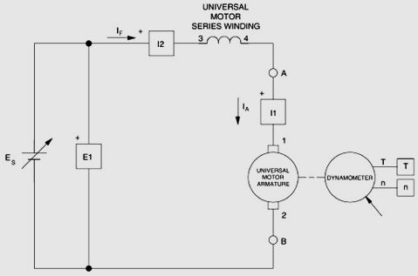

**Figure 3-12. DC-Powered Universal Motor Coupled to a Dynamometer.**

In the Metering window, set meters E arm. (EA), I arm. (IA), and I field (IF) in the dc mode.

15. Turn the Power Supply on and slowly turn the voltage control knob until the universal motor rotates at a speed of 1000 r/min ± 25 r/min. Check that both the armature current IA and the field current IF are positive. Record the source voltage ES and the direction of rotation.

ES = V

Direction of rotation:  (IA and IF = positive)

Turn the Power Supply off.

16. On the Power Supply, reverse the connection of the leads at terminals 7 and N to reverse the polarity of the voltage applied to the universal motor.

Turn the Power Supply on and slightly adjust the voltage control knob until the universal motor rotates at a speed of 1000 r/min ± 25 r/min. Check that both the armature current IA and the field current IF are negative. Record the source voltage ES and the direction of rotation.

ES = V

Direction of rotation: (IA and IF = negative)

Turn the Power Supply off.

What is the direction of rotation when the armature current IA and the field current IF are of the same polarity?



17. Reverse the armature connection at points A and B shown in Figure 3-12.

Turn the Power Supply on and slightly adjust the voltage control knob until the universal motor rotates at a speed of 1000 r/min ± 25 r/min.

|  |
| --- |
| ***Note: Neglect the sign of the speed indicated by the Speed meter in the Metering window.*** |

Check that the armature current IA is positive and the field current IF is negative. Record the source voltage ES and the direction of rotation.

ES = V

Direction of rotation:  (IA = positive, IF = negative)

Turn the Power Supply off.

18. On the Power Supply, reverse the connection of the leads at terminals 7 and N to reverse the polarity of the voltage applied to the universal motor.

Turn the Power Supply on and slightly adjust the voltage control knob until the universal motor rotates at a speed of 1000 r/min ± 25 r/min.

|  |
| --- |
| ***Note: Neglect the sign of the speed indicated by the Speed meter in the Metering window.*** |

Check that the armature current IA is negative and the field current IF is positive. Record the source voltage ES and the direction of rotation.

ES = V

Direction of rotation:  (IA = negative, IF = positive)

Turn the voltage control knob fully counterclockwise and turn the Power Supply off.

What is the direction of rotation when the armature current IA and the field current IF are of opposite polarity?



Does a universal motor act similarly as a series motor when it is powered by a dc source?

Yes No

Reverse the armature connection at points A and B shown in Figure 3-12. The modules should be connected as shown in Figure 3-12.

**Universal Motor Operating on AC Power**

19. Replace the variable-voltage dc source in the circuit with a variable-voltage ac source.

In the Metering window, set meters E arm. (EA), I arm. (IA), and I field (IF) in the ac mode.

Turn the Power Supply on and slowly turn the voltage control knob until the universal motor rotates at a speed of 1000 r/min ± 25 r/min. Record the source voltage ES and the direction of rotation.

ES = V (without compensating winding)

Direction of rotation:  (IA and IF of the same polarity)

Does the universal motor rotate in the same direction as when it was operating on dc power with IA and IF of the same polarity (steps 15 and 16)?

Yes No

Turn the Power Supply off.

20. Reverse the armature connection at points A and B shown in Figure 3-12.

Turn the Power Supply on and slightly adjust the voltage control knob until the universal motor rotates at a speed of 1000 r/min ± 25 r/min.

|  |
| --- |
| ***Note: Neglect the sign of the speed indicated by the Speed meter***  ***in the Metering window.*** |

Record the source voltage ES and the direction of rotation.

ES = V (without compensating winding)

Direction of rotation:  (IA and IF of opposite polarity)

Does the universal motor rotate in the same direction as when it was operating on dc power with IA and IF of opposite polarity (steps 17 and 18)?

Yes No

21. On the Power Supply, slowly turn the voltage control knob until the universal motor stops rotating.

Record in the following blank space the armature impedance ZA of the universal motor indicated by the impedance meter B

ZA =Ω (without compensating winding)

Turn the voltage control knob fully counterclockwise and turn the Power Supply off.

Compare the dc and ac source voltages ES required to make the universal motor rotate at a speed of approximately 1000 r/min. Briefly explain why they have different values.





Compare the dc voltages required to make the universal motor and the series motor rotate at a speed of approximately 1000 r/min.





Compare the ac voltages required to make the universal motor and the series motor rotate at a speed of approximately 1000 r/min.

Reverse the armature connection at points A and B shown in Figure 3-12.

**Effect of the Compensating Winding**

22. Modify the connections to connect the compensating winding of the Universal Motor as shown in Figure 3-13.

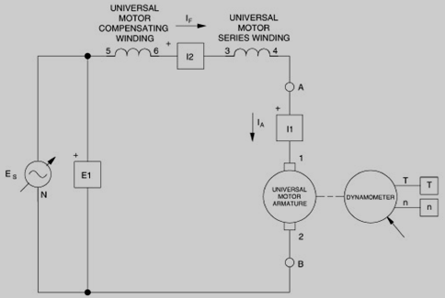

**Figure 3-13. AC-Powered Universal Motor (with Compensating Winding) Coupled to a Dynamometer.**

Turn the Power Supply on and slowly turn the voltage control knob until the universal motor rotates at a speed of 1000 r/min ± 25 r/min. Record the source voltage ES.

ES =V (with compensating winding)

On the Power Supply, slowly turn the voltage control knob until the universal motor stops rotating.

Record in the following blank space the armature impedance ZA of the universal motor indicated by the impedance meter B

ZA =Ω (with compensating winding)

Turn the voltage control knob fully counterclockwise and turn the Power Supply off.

Compare the ac source voltages ES required to make the universal motors with and without compensating winding rotate at a speed of approximately 1000 r/min. Briefly explain why they have different values.

23. On the Power Supply, set the 24 V - AC power switch to the O (off) position.

Remove all leads and cables.